

Final report of the Aged Care Taskforce



Contents
Synopsis 3
Introduction 4
The need for change 5
Aged care funding principles 11
Recommendations 12
Support older people to age in place 16
Equitable and sustainable funding 19
Quality, innovation and transparency 38
Appendix A: Aged Care Taskforce Terms of Reference and membership 45
Appendix B: Consultation 48
Appendix C: Statistical trends 50
Appendix D: Aged care funding principles 55
Appendix E: Current aged care participant contributions 58
Appendix F: Glossary of terms 60

Synopsis
The recommendations proposed by the Aged Care Taskforce (the Taskforce) support an aged care system that is sustainable, fair and facilitates greater innovation in the sector. A sustainable, or financially sound, aged care sector is necessary to attract additional investment and ensure the sector is set up to deliver quality care for older people into the future.
For older people using aged care services, the recommendations also support a system that provides quality care when it is needed, and is simpler, more flexible and transparent. The system should enable those who wish to age in place to do so. Rules will continue to ensure equitable access for people with low means, with co-contributions from those who have the means. Government funding will focus on ensuring all older people can access the care they need, while co-contributions will be required for the things people have typically paid for their whole lives, such as daily living expenses and, for those in residential care, accommodation costs.
For providers, the recommendations support more predictable and sustainable funding in home care, and increased capacity to cover the costs of delivering services in residential care. More broadly, this would help to strengthen the financial viability of the residential care sector to encourage different forms of investment. In home care, the Taskforce recommends greater clarity for participants and providers through clearly defined inclusion and exclusion principles and service lists. There will also be an important continuing role for government support in thin markets.

Introduction
Australia’s aged care needs are increasing as the population ages, and expectations of quality improvements are high. However, the aged care sector is currently not in a financial position to meet expected demand, deliver on the required quality improvements or invest to meet Australia’s future aged care needs.
A new approach to funding arrangements is critical to support an aged care system which is sustainable, fair and facilitates greater innovation in the sector. Only a financially sound aged care sector will attract the additional investment required to deliver quality care for older people.
The Taskforce was established to advise on funding arrangements, including:
- a fair and equitable approach to assessing the means of older people
- participant contributions for home care
- reforms to arrangements for pricing and funding of hotel and accommodation costs in residential aged care, including the phasing out of Refundable Accommodation Deposits (RADs)
- services for inclusion and exclusion in the new home aged care program
- funding and contribution approaches to support innovation in the delivery of care.
The Taskforce consisted of 16 members with broad experience and expertise across health and aged care, banking and finance, economics and public policy including representatives of providers, current and future aged care participants, younger people, and diverse cohorts. It was chaired by the Minister for Aged Care and Sport, the Hon Anika Wells MP. The Taskforce Terms of Reference and members are at Appendix A.
Taskforce meetings were held monthly from June to December 2023 to develop the advice in this report. Taskforce members also consulted widely to support their deliberations. This included receiving 180 written submissions, 1,944 survey responses, and holding 12 forums with 98 online attendees and 312 in-person attendees, and 11 targeted roundtables with 105 attendees. The voices of older people were central to the Taskforce’s consultations and deliberations. Members also consulted independently with their networks to support their understanding and develop views. More information on Taskforce consultation is at Appendix B.
Taskforce members held robust discussions on a range of topics, and the recommendations in this report reflect their consensus view. However, differences of opinion remain among Taskforce members.
During their discussions, the members noted issues outside the direct scope of the Taskforce. These included the role a well-functioning aged care system could play in reducing demands on the wider health and hospital system, and the role of the workforce in the system’s ability to scale up to meet future demand, particularly through ongoing workforce challenges. Despite these being out of scope, the Taskforce notes further work needs to be done on:
- workforce attraction and retention issues and their impact on quality care outcomes, and identifying workforce initiatives that would improve quality outcomes across the sector
- improving the interface between aged care and the wider health and hospital system to streamline services and reduce waiting times for hospital patients needing placement in residential aged care. This will be progressed through negotiations around the National Health Reform Agreement.
The Taskforce acknowledges the high level nature of some of its recommendations. This reflects the need for more detailed thinking on complex issues, which was not possible during the Taskforce’s timeframe. This report notes where further thinking is needed by government. The Taskforce also notes the continued importance of wide government consultation during this next phase of work.

The need for change
The Australian community expects, and wants, older people to be able to live well and receive the care they need as they age.
The role of, and demands on, the aged care system have changed considerably over recent decades and will continue to do so as participants’ needs become more complex and community expectations evolve.
Outcomes of the Royal Commission into Aged Care Quality and Safety (Royal Commission), as well as other reviews, have shown significant work needs to be done. In particular, the Royal Commission identified the need to improve the quality of aged care, increase workforce availability and capacity, and ensure the sector meets community expectations.
The Taskforce has identified the following issues affecting the aged care sector:
- demographic change means demand for aged care services will continue to grow
- current and future generations of aged care participants have high expectations of what quality aged care looks like
- additional funding is needed to meet future demand and deliver quality improvements, but structural issues mean the sector’s financial viability is poor
- generally older people are wealthier than previous generations and the taxpayer base is declining as a proportion of the population.
The recommendations in this report aim to position the sector to address these issues.

The Royal Commission identified quality issues and issues relating to the workforce
The Royal Commission was established in October 2018 to inquire into the quality and safety of aged care services in Australia, whether those services were meeting the needs of the community, and how they could be improved in the future. The Royal Commission reported in 2021, finding there was a need to significantly improve the quality of both residential and home care in Australia, and that chronic workforce shortages were leading to substandard care.
The Royal Commission made 148 recommendations, aimed at supporting older people living in Australia to age well and improving the quality and safety of aged care services in Australia. The government has accepted the vast majority of the recommendations and is midway through implementing widespread reforms to improve the quality and safety of aged care, including significant increases in funding and the development of a person-centred new Aged Care Act.
The government has made significant investments in the sector, delivered on workforce requirements including minimum care minutes and 24/7 nursing, and has funded wage increases for aged care workers. However, increased funding is needed to support further improvements and better quality aged care for current and future generations of participants. A skilled workforce will be critical to the ability to deliver high quality and person-centred care. This work is ongoing and outside the scope of the Taskforce.

Demographic change means demand for aged care services will continue to grow
Australians are living longer than ever before. However, living longer often comes with greater frailty and more complex care needs late in life. This means demand for aged care is increasing and the type of services required are changing. The aged care sector needs to adapt to this change. With more people living longer and requiring a range of care in their later years, services will need to continue to expand and improve.
Australia’s old-age dependency ratio measures the number of people aged 65 and over for every 100 people of traditional working age (15 to 64). In 2022–23 this proportion was 26.6% and it is expected to increase to 38.2% by 2062–63. This reflects the size of the population aged 65 and over growing faster than the working age population. Over the next 40 years, the number of people over 80 years of age is expected to triple to more than 3.5 million. These demographic shifts have 2 critical implications:
- the taxation burden for funding aged care services grows for a segment of the population that is becoming proportionally smaller
- gaps in the aged care workforce increase, creating significant ongoing challenges to delivering quality care.
Total government spending on aged care in 2021–22 was $24.8 billion. As a result of population ageing, the cost of delivering aged care will require a greater proportion of government funding into the future. Government spending on aged care as a proportion of gross domestic product (GDP) is projected to grow from 1.1% in 2021–22 to 2.5% in 2062–63.
The demand for home care has been rising sharply and is projected to continue growing well into the future. These changing preferences of older people mean the profile of demand for aged care services will shift in favour of care in the home. The average length of time people access home care has also increased. As people remain at home with greater frailty, the home care system needs to be able to meet these more complex care needs.
Over the next 20 years an average annual increase of 44,000 participants is forecast each year, totalling almost 2 million older people using home care by 2042, compared with around 1 million currently. To meet this demand, the home care sector will need to be financially stable and administratively efficient.
More detail on statistical trends is at Appendix C.

Current and future generations of aged care participants have high expectations of what quality aged care looks like
Over the next few decades, the cohort of older people is expected to become more diverse, with more varied care needs and expectations. Older people, and the community generally, expect the aged care system will continue to evolve to offer increased quality, greater choice and more control for participants. Older people expect a greater say in what is delivered, how and when.
There is a desire for increased autonomy and choice in aged care services generally. Higher income and wealth are accompanied by a greater desire to purchase additional and higher quality services. More broadly, society is demanding higher quality aged care services for all, including participants supported by government. For example, research on public understanding and perception of co-contributions in aged care showed people are willing to pay more for home care services that are essential and increase quality of life and dignity.
Quality care ensures the dignity and human rights of every participant. Quality also requires a holistic, individualised approach to each participant’s health, rather than a purely medical model. Taskforce consultation also found that individuals see being empowered to make their own informed decisions as part of quality care.

Additional funding is needed to meet future demand and deliver quality improvements, but structural issues mean the sector’s financial viability is poor
To ensure the aged care sector can meet increasing demand and community expectations, further investment from government and participants is needed in the home and residential care sectors.
The new Support at Home Program will be implemented in 2 stages, replacing the current Home Care Packages Program from 1 July 2025 and then rolling in the Commonwealth Home Support Programme from no sooner than 1 July 2027. This revised program will streamline and improve access over time for the one million people receiving these services. The individual programs currently require people to wait for much needed services and if the current program funding settings are maintained, wait times are expected to increase.
Even with changing preferences in favour of home care, the ageing population means aggregate demand for residential aged care will also continue to grow. Preliminary analysis undertaken for the Department of Health and Aged Care estimates an investment of $37 billion (in today’s dollars) would be required to build the additional aged care rooms needed by older people in 2050. Over the next decade to 2030, additional investment of approximately $5.5 billion would be required to refurbish and upgrade existing aged care rooms, increasing to $19 billion by 2050. Current funding arrangements will not deliver the required amount of capital funding.

Despite increased government investment, 69% of residential aged care providers made an operating loss in 2021–22, an increase from 54% in 2020–21. While this is an expected low point for the sector, and performance has begun to improve, providers remain constrained in where they can earn revenue, particularly for accommodation and everyday living expenses. Providers rely on RADs for capital funding, but this creates liquidity risks and does not directly provide revenue to the sector. While some cyclical factors, such as low interest rates (up until 2022) and falling occupancy rates contributed to these results, the system wide losses are driven by structural issues and rigid pricing structures.
The home care sector is more viable, but also faces emerging financial challenges. In 2021–22, 69% of providers reported an operating profit, a decline from 74% in 2020–21. As the home care sector grows in scale, there is a need to ensure it is on a stable footing with capacity to scale services and support quality of life for older people.
Unless the aged care sector’s financial viability improves, it will be difficult to attract investment, either as debt or equity. Improved financial viability is necessary to deliver improvements in service, quality and to address service gaps.
To help improve financial viability and the quality of pricing of services in aged care, the role of the hospital pricing regulator was broadened in 2022 to include aged care and it was renamed the Independent Health and Aged Care Pricing Authority (IHACPA). It has recently commenced providing aged care pricing advice on subsidies and supplements to be paid for residential aged care and residential respite care. It will also provide annual advice to government on home care prices under the new Support at Home Program. The advice covers residential aged care hotelling (called everyday living in this report) and care costs, and includes a weighting for rural and remote areas. While this will support improved pricing, there are regulations limiting the ability to set prices to cover costs in some areas and policy changes will be necessary to make progress on sector viability issues.

Older people are wealthier than previous generations, and the taxpayer base is declining as a proportion of the population
Generally, older people are expected to be wealthier than their predecessors, largely due to the maturing superannuation system. As a result, the proportion of people over 65 years of age accessing the Age Pension or other income supports will decline by around 15 percentage points by 2062–63. Of those receiving a pension, fewer will be full-rate pensioners and more will receive a part-rate pension due to increased accumulation of income and assets. Over the next 20 years, the number of people with superannuation balances at age 85 will grow considerably, with a greater proportion of people having significant funds available.


The Taskforce notes the superannuation system supports Australians to save for retirement. The government’s proposed objective for superannuation is: ‘to preserve savings to deliver income for a dignified retirement, alongside government support, in an equitable and sustainable way’. Income from superannuation should be drawn down in retirement to cover health, lifestyle, other living expenses and aged care costs.
These superannuation trends, combined with high asset wealth through the family home and other investments, mean increasingly people still have accumulated wealth and income streams when they need to access aged care services. As a result, there is more scope for older people to contribute to their aged care costs by using their accumulated wealth than in previous generations.
It is important to note that, while the asset wealth of many older people has increased, there will be a group of people with less means. Even with the maturing superannuation system, over half of older people will continue to receive some Age Pension either at retirement or as they draw down on their superannuation. Past workforce participation rates also mean women are more likely to have less means in retirement, as are those who do not own their home.
As older people are generally becoming wealthier, intergenerational gaps are increasing. The home ownership rates among older people aged 65 years and over was around 82% in 2021 and has been fairly stable since the mid–1980s, whereas home ownership for younger generations has been trending downwards over that time. The tax burden, and therefore the cost of government services, is being shared among an increasingly smaller group of people as the proportion of the working age population declines and the proportion of older people, most of whom do not pay income tax, increases.
Summary of aged care funding principles and recommendations
Consultation informed 7 aged care funding principles that guided the work of the Taskforce. These are summarised below and more information is at Appendix D.
The Taskforce has made 23 recommendations linked to these principles, which are also summarised below.


Aged care funding principles

Support older people to age in place
Principle 1: The aged care system should support older people to live at home for as long as they wish and can do so safely.

Equitable and sustainable funding
Principle 2: Aged care funding should be equitable, easy to understand and sustainable.
Principle 3: Government is and will continue to be the major funder of aged care. Government funding should be focused on care costs as well as delivering services in thin markets. Personal co-contributions should be focused on accommodation and everyday living costs with a sufficient safety net.
Principle 4: The residential sector should have access to sufficient capital to develop and upgrade accommodation, including in rural and remote areas and First Nations communities.

Quality, innovation and transparency
Principle 5: Aged care funding should be sufficient to deliver person-centred, quality care by a skilled workforce.
Principle 6: Aged care funding should support innovation to improve aged care services and their relationship with the health and hospital systems.
Principle 7: There should be transparency and accountability for how aged care funding is received and spent while minimising regulatory burden.

Recommendations

Support older people to age in place
Recommendation 1:
Underpin the Support at Home Program with inclusion and exclusion principles and clearly defined service lists.

Equitable and sustainable funding

Balancing government funding and participant contributions
Recommendation 2:
Continue the significant role for government funding of aged care services. A specific tax or levy to fund aged care is not recommended.
Recommendation 3:
It is appropriate older people make a fair co-contribution to the cost of their aged care based on their means.
Recommendation 4:
Ensure a strong safety net for low means participants to meet aged care costs.
Recommendation 5:
Make aged care fees fairer, simpler and more transparent so people can understand the costs they will incur if they access aged care.
Recommendation 6:
Establish appropriate arrangements to allow older people and providers to smoothly transition to any new arrangements, including grandparenting arrangements for those already in residential aged care and phasing in for home care.

Greater equity in home care participant co-contributions
Recommendation 7:
Establish a fee-for-service model for Support at Home that ensures participants only pay a co-contribution for services received.
Recommendation 8:
Introduce Support at Home participant co-contributions that vary based on the type of service accessed.

Government funding focused on care
Recommendation 9:
Continue to focus government funding in residential aged care on care costs, with a significant role for resident co-contributions in non-care components.

Better priced and more flexible daily living co-contributions
Recommendation 10:
Funding for daily living needs to cover the full cost of providing these services. It is recommended this be composed of the Basic Daily Fee and a supplement.
Recommendation 11:
Enable residents and their representative and providers to negotiate better or more daily living services for a higher fee, subject to at least:
- publishing prices and services
- only allowing agreement to higher fees for agreed services to be made after a participant has entered care
- a cooling off period and regular review opportunities to ensure the resident still wants the services and can still use them.

Modernising accommodation funding and improving viability
Recommendation 12:
Following an independent review in 2030, transition the sector by 2035 to no longer accept RADs as a form of payment for aged care accommodation and move to a rental only model, provided that the independent review finds there is improved financial sustainability, diversified and adequate sources of capital to meet future demand and residential aged care is affordable for consumers.
Recommendation 13:
Require providers to retain a portion of the RAD in the near-term to make an immediate improvement to sector financial sustainability. Base the amount on length of stay, with a cap on the number of years a RAD is subject to retention to protect residents who stay for a long time.
Recommendation 14:
Review the Accommodation Supplement, including improving incentives to meet the accommodation design principles.
Recommendation 15:
In addition to the other accommodation recommendations, develop a package of measures to improve accommodation funding, equity between residents and transparency in the near-term. This will help place accommodation income on a long-term sustainable footing and position the sector for the ultimate phase out of RADs.
Recommendation 16:
Establish appropriate safeguards and incentives to protect access to residential care for supported residents.

Supporting thin markets
Recommendation 17:
Consider the appropriateness of the current remoteness classification system.
Recommendation 18:
Continue block funding in thin markets where appropriate and necessary. Consider any other supports necessary to ensure access to care in under serviced markets.

Quality, innovation and transparency

Encouraging innovation in the sector
Recommendation 19 :
Consider ways to encourage providers to develop and scale innovative care models, invest in technology, and conduct research into best practices, including through:
- the recommendations outlined in this report to improve the viability of the aged care sector
- tasking the Aged Care Quality and Safety Commission with supporting innovation by identifying innovative practices and promoting these across the sector.

Increasing transparency and planning for aged care
Recommendation 20:
Raise awareness of existing financial products that enable older people to utilise their wealth in retirement and provide confidence they can afford future aged care costs.
Recommendation 21:
Task the Behavioural Economics Team of the Australian Government (BETA) to provide advice on how to encourage people to consider their future aged care needs at an appropriate stage of life.
Recommendation 22:
Review and streamline financial reporting to government where possible to ensure reporting is genuinely enhancing transparency.
Recommendation 23:
Improve communications between the Independent Health and Aged Care Pricing Authority (IHACPA) and providers and participants regarding its pricing advice and decisions, and task IHACPA with:
- a review of its pricing in rural and remote areas
- costing of the supplement for everyday living.

Support older people to age in place
Principle 1: The aged care system should support older people to live at home for as long as they wish and can do so safely.
A strong preference for many older people and their families is for them to age in place and remain in their home for as long as they are able. This was reflected in responses to the stakeholder survey, with 90% of respondents supporting the principle.
The decision of whether an older person wishes to remain at home or enter residential aged care is driven by a wide range of factors. Consultation showed the top reasons for preferring to remain at home included comfort and privacy, a desire to remain independent, better mental and physical health outcomes and maintaining connection to community, friends and family. For other reasons, such as social connectedness, increasing clinical care and safety needs, some older people may choose to enter residential aged care sooner. While overall there is a shift towards ageing in place, it is important to meet each person’s preferences for their aged care and provide continuity of care when needs change.

Home care programs need an overhaul to meet future demand
The current home care programs are not ready to meet the needs of a rapidly growing cohort of older people. Home care currently involves 2 programs, the Home Care Packages Program and the Commonwealth Home Support Programme, that have evolved over time and with different design objectives. This has led to a system where:
- applicant assessments are inconsistent and not well aligned to actual need
- access to services is constrained and inconsistent, and many older people are not receiving an optimal mix of services
- services are priced and fees are charged inconsistently (see Appendix E for details)
- different funding approaches are impeding the sector from scaling up and diversifying
- there is a lack of clarity about what services should be available.
Those who can access home care under the current system can leave significant funds unspent, while others can wait for months to access services. This is due to existing program constraints, limited availability of services and appropriately skilled workers, as well as behavioural and attitudinal factors. In the Home Care Packages Program, unspent funds as at 30 June 2022 totalled $2.3 billion. Prices across the programs are inconsistent and inefficient due to variable price setting arrangements. This undermines the predictability and sustainability of funding and can cause confusion when comparing packages with other participants.

There are also obvious signs of lack of scale and diversification of providers. As the population ages, these issues will need to be addressed to deliver a rapid scaling up of services to meet demand.

The Support at Home Program is an opportunity for generational change in how home care is delivered
It will also be important to make sure home care better meets older people’s needs, while enabling program scalability and pricing signals that ensure funds are used consistently and in line with program intent. In addition, home care must provide value for money, transparency and better quality services.
The new Support at Home Program, to be introduced in stages from July 2025, is an opportunity to address these critical issues in the current home care programs.
As the Support at Home Program is implemented, it will be important to ensure the new arrangements deliver on the intent of the design and meet the expectations of older people, their families and carers for:
- greater choice and control
- easier and more timely access
- flexibility to adjust services over time as needs change
- better value for money through controls on unreasonable administration fees
- better clarity and transparency around fees and how funding is used.
It is also important that the new arrangements deliver for providers, acknowledging the need for:
- more predictable and sustainable funding that meets the costs of quality service delivery
- recognition of the costs associated with complying with regulatory requirements
- flexibility to adjust services on the ground as participant needs change
- improved use of a qualified and skilled workforce to increase service availability
- appropriate and adequate implementation timeframes.

Support at Home Program inclusions and exclusions need to be more clearly defined than under current programs
The Taskforce was asked to provide advice on program inclusions and participant contributions for the Support at Home Program. In developing this advice, the Taskforce considered the diverse needs, goals and circumstances of participants, the intent of the program and the role of other service systems. The importance of prevention, flexibility and reablement also played a key role in discussions.
The Taskforce notes the Support at Home Program needs much clearer specifications than current programs about what it will and will not fund. The lack of clarity and consistency in inclusions and exclusions in current home care programs has led to confusion between providers and participants. This affects participants’ ability to make informed choices about their care, diminishes value for money in the programs, and could also mean that funds are not used according to the policy intent of home care.
Recommendation 1 :
Underpin the Support at Home Program with inclusion and exclusion principles and clearly defined service lists.
These inclusion and exclusion principles are set out below.
Inclusion principles | Exclusion principles
- Services that have been assessed as essential or necessary for health, independence or safety in the home.  - Services that are reasonable based on assessment of value for money and whether alternatives may adequately address need. | - Services, goods or supports that people are expected to cover out of their general income throughout their life regardless of age or wealth.  - Accommodation costs (for example, rent, mortgage fees, rates, strata levies, home insurance, utilities).  - Services already funded, or more appropriately funded, under other Commonwealth, state, territory or local government programs.  - Payment of Support at Home co-contribution fees.  - Payment for informal care which is covered by other Commonwealth programs.  - Provision of cash debit cards or like payments to care recipients for any purpose.  - Activities that the community would not accept as suitable for government funding.  - Activities likely to cause harm to the participant or pose a risk to others.
The aim of the exclusions principles is to clearly describe what services are outside the scope of the Support at Home Program and therefore do not receive funding from the government (such as utility bills). However, the Taskforce supports flexibility in exceptional circumstances. This would enable a participant to receive an excluded service or item if the alternative is a perverse outcome for the participant and government. For example, where a participant is at risk of entering residential aged care or hospital but for delivery of a comparatively affordable service or item at home. This flexibility would need to be developed in a way that ensures efficient and effective expenditure.
The Taskforce supports the use of these principles to develop inclusion and exclusion lists to ensure program integrity and improve consistency. This would clearly identify which services are provided or not provided through the program. The lists would need to be reviewed periodically to ensure they are responsive to innovation and older people’s needs, including for those who rent.

Home care interacts with other social services, and there is a need for these systems to interact more smoothly
The Taskforce notes the aged care system is not intended to provide services and supports that are provided by other systems, such as health and housing services delivered by the states and territories.
However, there is a role for aged care services in enabling better coordination of the wide range of services an older person may need across government agencies and levels of government, such as specialist palliative care. The Taskforce notes more work is required to improve this coordination.

Equitable and sustainable funding
Principle 2: Aged care funding should be equitable, easy to understand and sustainable.
Principle 3: Government is and will continue to be the major funder of aged care. Government funding should be focused on care costs as well as delivering services in thin markets. Personal co-contributions should be focused on accommodation and everyday living costs with a sufficient safety net.
Principle 4: The residential sector should have access to sufficient capital to develop and upgrade accommodation, including in rural and remote areas and First Nations communities.
Older people should be able to access aged care support where they need it, when they need it, and how they need it. Culturally safe and appropriate services also need to be considered for First Nations peoples, including the Stolen Generations, and culturally and linguistically diverse people.
However, the costs of providing residential and home care services will continue to rise substantially into the foreseeable future. This is driven by the demographic trends noted earlier, the requirement for the sector to meet increasingly complex care needs, changing community expectations for higher quality services, and greater flexibility and transparency.

Balancing government funding and participant contributions

Increasing aged care funding through additional taxation would exacerbate intergenerational inequity
The Royal Commission suggested creating a levy, similar to the Medicare Levy, to fund aged care. Both Royal Commissioners Pagone and Briggs were in favour of income tax increases to fund aged care costs, although their models differed.
The Taskforce considered these and other options, some raised via consultations, including an increase to the Goods and Services Tax (GST).
While the Taskforce supports government maintaining its central role in funding aged care, it does not support a specific increase to tax rates to fund future rises to aged care funding. There are substantial intergenerational equity issues in asking the working age population, which is becoming proportionally smaller to pay for these services. Moreover, superannuation has been designed to support people to grow their wealth and fund the costs associated with retirement including aged care.
Recommendation 2 :
Continue the significant role for government funding of aged care services. A specific tax or levy to fund aged care is not recommended.

As demand for aged care grows there will be a greater role for participants in funding a sustainable system
Government funding constitutes around 75% of the total costs of residential aged care funding, and 95% of home care funding.
The Taskforce considers this is not an optimal or fair mix. Given the increasing wealth of many older people and the declining working age (that is tax paying) population, there is a strong case to increase participant co-contributions for those with the means to contribute, noting that there will always be a group of participants who need more government support.
Recommendation 3 :
It is appropriate older people make a fair co-contribution to the cost of their aged care based on their means.

The Taskforce also believes it is important for co-contribution arrangements to be consistent and proportionate between the Support at Home Program and residential care (for example, consistency of the costs paid for by government and those paid for by participants). It will also be important that co-contribution arrangements do not increase barriers to older people moving between home care and residential care.

The need for support for low means participants will continue
While the overall wealth of older people is growing, there will continue to be a substantial number of people with limited means. For example, full-rate pensioners without assets, such as a house, or people whose circumstances diminish while in aged care. It is essential to maintain support to ensure everyone can access the aged care services they need. The Taskforce strongly affirms the need to retain financial supports for residential care providers to care for residents who have low means (supported residents). Consultations showed high community support for a strong safety net, with 89% of respondents to the consultation survey agreeing the government should cover aged care costs for those who cannot afford to pay.
There are already strong funding arrangements in place for low means participants in aged care, which need to be preserved. The Taskforce has not made specific recommendations on the long-term safety net requirements, but recognises there will be implications for settings as details of the recommendations on participant co-contributions in residential and home care are further developed. Settings will need to ensure those who cannot make a greater contribution are not asked to do so, and rules are in place to support equitable access to high quality aged care services for all participants, regardless of their means.
Recommendation 4 :
Ensure a strong safety net for low-means participants to meet aged care costs.

The current fee system is complex and participants would benefit from simpler and fairer aged care fees
Aged care co-contribution arrangements are complex, particularly in residential care, and have to be navigated at a difficult time in life. Even if a person has been accessing home care and is one of the minority currently paying fees, the residential care co-contribution arrangements are very different. Taskforce consultations found there was a need for information to be more transparent and simpler so older people could make informed decisions.
Reforming co-contributions would also provide an opportunity to create a simpler and fairer system by addressing inequities currently created by different reporting and assessment processes used for the Age Pension and aged care means assessments.
Recommendation 5 :
Make aged care co-contributions fairer, simpler and more transparent so people can understand the costs they will incur if they access aged care.

The Taskforce suggests the Age Pension status of the participant, with some additional tiers for part-pensioners and non-pensioners, would be a fair and simple way to determine participant co-contributions for aged care services. Age Pension status is widely understood by older people, their families and the community more generally. It would also enable people to generally understand the fees applying to them from Age Pension age, rather than at the time they need care.
Additional tiers may be required to ensure arrangements are equitable at all levels. For residential aged care, some adjustments would also be required to incorporate home ownership status. For non-pensioners, there may be an opportunity for additional differential means testing arrangements based on Commonwealth Seniors Health Card status. Further work is needed to analyse these options before consideration by government.

A careful and staged transition plan is necessary to protect existing participants
Those already in residential care should not be adversely affected by any changes. Historically, ‘grandparenting’ is used so residents continue to pay co-contributions based on the rules in place when they entered care. However, new residents would be subject to new arrangements following a transition period to allow older people and providers time to plan for the changes. Exact timing would be a matter for government as part of implementation.
Phasing in the Support at Home Program will need to be carefully considered, so participants and providers have enough time to understand and prepare for change.
Recommendation 6 :
Establish appropriate arrangements to allow older people and providers to smoothly transition to any new arrangements, including grandparenting arrangements for those already in residential aged care and phasing in for home care.

Greater equity in home care participant co-contributions
At just 5% of total funding, current participant co-contribution rates in home care (Commonwealth Home Support Programme and Home Care Packages Program) are extremely low and will not support the projected growth in demand. As the role of home care in Australia’s aged care system expands, participant co-contributions towards everyday living type expenses will need to increase alongside government funding.

A fee-for-service approach with clearly defined service lists would mean home care participants only pay for services received
The Taskforce supports a co-contribution approach based on fee-for-service that ensures participants only contribute to the cost for services they receive. This approach to participant contributions would result in improved value for money and pricing transparency. This in turn would ensure all funds for home care are used efficiently in line with the intent of the program, enabling more people to receive services.
Recommendation 7 :
Establish a fee-for-service model for Support at Home that ensures participants only pay a co-contribution for services received.
The Taskforce supports the inclusion and exclusion principles being used to develop clearly defined service lists for the items available through the Support at Home Program, and the levels of government and consumer co-contribution relating to the specified services.
Improved co-contribution arrangements on a fee-for-service basis would provide price signals for participants to help them prioritise their service needs. It would also improve fairness for participants and reduce the administration costs in home care packages.
Fee-for-service, combined with service caps, would provide guidance to help participants prioritise their service use for essential services. It would also help make the Support at Home Program more financially sustainable and better placed to meet future demand.
A detailed service list is not included in this report. The Taskforce acknowledges the need for further work by government on this, as well as consultation with participants and providers to avoid unintended consequences, before final decisions are made and implementation begins.

Participant co-contributions would support growth of the home care system and improve access to services
While government would continue to be the major funder for aged care, the Taskforce believes greater participant co-contributions would enable home care to expand in an equitable way, provide greater access to better quality and flexible services for participants and support the expansion of a skilled workforce.
Increased participant co-contributions under the new Support at Home Program would also directly improve access to home care by:
- helping to reduce demand pressure, by creating a direct incentive for participants to use only what they are assessed as needing
- enabling upfront access to services rather than waiting for funds accrual, especially through the development of a new Assistive Technology and Home Modifications Scheme
- contributing to improving system functionality for generations to come.
As with Recommendation 5, the Taskforce suggests Age Pension status would be a well-understood way to determine co-contribution levels in home care. Support at Home Program services could be classified into 3 service lists with different co-contributions allocated to each:
- Clinical supports – government contributions would be highest, and consumer co-contributions lowest (if any) for supports that are essential to prevent decline in health (for example, nursing assistance to assess, identify and deliver care to manage health decline issues, and allied health services).
- Independence – a middle tier would include items that may support independence and reablement (for example, personal care services and assistance with food preparation).
- Everyday living – participant contributions would be highest for services that someone not in the Support at Home Program would typically pay for in full (for example, general house cleaning).
The Taskforce considers that services in the ‘Clinical supports’ list should be fully funded by government.
Recommendation 8 :
Introduce Support at Home participant co-contributions that vary based on the type of service accessed.
This approach would allow:
- contributions that vary depending on the services participants use
- government to fully or predominantly fund certain core services focusing on clinically orientated care
- a price signal for other services to encourage participants to prioritise their health care needs and better reflect what people would pay for throughout their lives to live in their own homes regardless of age
- individuals who are covered by safety net arrangements to continue to receive services with a minimal co-contribution
- people to access more services in their home that they have not previously been able to receive, such as dementia supports.
There would need to be a transition process to these new arrangements. While the transition will be developed by government, the Taskforce considers it could occur as participants’ care needs change.

Jenny and Joyce are part-pensioners with the same care needs, assets and income. They both participate in the Home Care Packages Program.
Jenny’s provider charges her a Basic Daily Fee and an income tested care fee. However, Joyce’s provider only charges the income-tested care fee.
Under proposed changes and following a period of transition, Jenny and Joyce would pay the same co-contributions for the same services under the Support at Home Program. Moreover, they would only be charged for services they receive.
Jenny and Joyce would pay higher co-contributions for everyday living services than for independence services with the lowest (if any) co-contributions paid for clinical supports.

Considering residential aged care recommendations as a package
There are currently 3 core fee categories in residential aged care:
- Means tested care fees, which contribute to the cost of care related services. The government pays most of these fees.
- The Basic Daily Fee, which covers the majority of everyday living expenses. This is a flat rate paid by all residents, currently fixed at 85% of the single basic Age Pension. The government pays a supplement for all residents in addition to the Basic Daily Fee.
- Accommodation costs, which cover the cost of the room and capital expenses, payable as either a daily payment or a fully refundable lump sum. Most residents make some contribution to these costs, with the role of government limited to providing a supplement for low means residents.

A holistic approach to reform across the 3 residential aged care fee categories is essential
The Taskforce considers the broad approach to the role of government funding and co-contributions across these categories is appropriate. However, there is a need to improve funding in the 2 areas (everyday living and accommodation) where providers are currently making substantial losses. Doing so will improve sector viability, which will increase the sector’s capacity to improve quality, accommodation and service offerings for residents.
While pricing may be set across the 3 fee groups, the Taskforce notes for most individuals, these are seen as one overall cost for their residential aged care. It is important to ensure residential aged care remains affordable and changes to co-contributions do not excessively draw down the assets of residents. The Taskforce has developed a balanced package of recommendations on co-contributions in residential aged care, with some trade-offs between fee categories, which considers capacity to pay, equity, fairness and transparency as key drivers.

Government funding focused on care
The Taskforce notes the government already has a significant role in funding ‘care’ in residential aged care through the Australian National Aged Care Classification (AN-ACC) model. Government funds around 94% ($13 billion) of this, with means-tested care co-contributions making up 6% ($800 million).
Currently, around half of residents contribute towards their care, with most only making a small contribution.
The Taskforce suggests government funding should continue to focus on assessed care needs, with residents making greater contributions to non-care components.
Recommendation 9 :
Continue to focus government funding in residential aged care on care costs with a significant role for resident co-contributions in non-care components.
However, the Taskforce also believes an approach expanding government funding to fully fund the care component should be considered, as this would be consistent with Royal Commission recommendations.
With this approach older people would not have to worry about being able to afford to pay for their assessed direct care needs. The care needs that come with increasing frailty and age-related conditions can be unexpected and significant, making it difficult for people to accurately plan for what their specific care needs and costs may be in old age. In contrast, the Taskforce recommends a greater co-contribution towards items that people have more likely paid for throughout their lives, like accommodation and daily living expenses, which are reasonably certain and can be planned. This approach would also simplify the contributions required from older people entering residential aged care.
For providers, this approach would reduce administration costs in collecting the means tested care fee and potentially reduce the amount of bad debts requiring management.
If government chooses not to fully fund care, it may wish to review current arrangements for care fees, including the potential for removing annual caps and reviewing lifetime caps.

Better priced and more flexible daily living co-contributions

There is a need for a general increase in the level of funding for everyday living in residential aged care
Providers currently receive 2 key payments relating to daily living activities. The larger payment is the Basic Daily Fee, which is set at 85% of the daily rate of the single basic Age Pension. This is currently $61 per day, and all residents pay this to providers. The other payment is the hotelling supplement, currently $11 per day, which government pays to providers for all residents, regardless of their means.
Aged care providers are on average losing $4 per resident per day on daily living activities and have little flexibility to earn additional revenue in this area.
There is therefore a critical need for increased funding towards everyday living expenses. The Taskforce believes this should be largely paid for through greater resident co-contributions to ensure sustainability, but with a strong means tested safety net for those who cannot pay a higher rate, such as full-rate pensioners with no other income or assets.
Recommendation 10 :
Funding for daily living needs to cover the full cost of providing these services. It is recommended this be comprised of the Basic Daily Fee and a supplement.
The Taskforce also suggests:
- the supplement should be the balance between the Basic Daily Fee and the actual cost to providers of everyday living
- the Basic Daily Fee should be maintained as a percentage of the Age Pension to ensure it remains affordable for those with low means
- government should continue to fully fund the supplement for lower means residents with residents of greater means paying some or all of the cost.
Further, IHACPA could be tasked with costing everyday living to assist with setting the price of the supplement (see Recommendation 23).

Fee flexibility would enable residents to elect to pay for better or additional everyday services if they wished
Provided appropriate consumer protections and complaints processes are in place, the Taskforce considers there is value in providing flexibility for residents, or their representatives, to negotiate a higher Basic Daily Fee with their provider so they can access additional services or amenities, if they have the willingness and means to pay.
This would allow greater flexibility and offerings for residents willing to pay and allow providers to diversify their offerings and obtain additional revenue.
Recommendation 11 :
Enable residents and their representatives to negotiate better or more daily living services for a higher fee, subject to at least:
- publishing prices and services
- only allowing agreement to higher fees for agreed services to be made after a participant has entered care
- a cooling off period and regular review opportunities to ensure the resident still wants the services and can still use them.
Without the protections outlined in the recommendation, the Taskforce suggests there would need to be a cap on the amount providers could charge. Further, the Taskforce believes there is a need for ongoing monitoring, with appropriate action taken to ensure protections are adequate and adhered to.
Kristy is a full-rate pensioner with no assets. The new arrangements would not change her contribution to everyday living costs, and they remain at 85% of the single basic Age Pension. The government would continue to pay the hotelling supplement.
Jagjeet is a self-funded retiree who is eligible for the Commonwealth Seniors Health Card.
If he enters residential aged care after the new arrangements commence, he would pay the hotelling supplement, and his everyday living costs would be higher than under current arrangements.
Both Kristy and Jagjeet could negotiate a higher Basic Daily Fee with their provider for more or better everyday living offerings, such as pay TV.

Modernising accommodation funding and improving viability
While recent investment in aged care has addressed adequacy of care funding, the residential aged care sector is still experiencing large and unsustainable losses. Two-thirds of residential aged care providers reported a net loss, equating to $2.26 billion in 2021–22. This is largely due to losses in accommodation activities.
Non-supported residents pay for their accommodation costs via a fully refundable lump sum RAD or rental style Daily Accommodation Payment (DAP) calculated from the lump sum price, or any combination of a RAD and DAP. The relationship between the RAD and DAP is based on an interest rate called the Maximum Permissible Interest Rate (MPIR), with the DAP calculated based on an agreed RAD at the level of the MPIR on the date of the resident’s entry.
A RAD payer receives their deposit back in full when they leave care. The provider earns a return on RADs by investing the funds, either by making capital improvements on their facilities or by investing in approved financial products.

The Royal Commission timeframe on RADs is not realistic given the state of the sector
The Royal Commission (Commissioner Briggs) recommended phasing out of RADs over time and replacing them with income through a ‘rental model’, where everyone pays with non-refundable periodic payments, from July 2025.
The Royal Commission identified several issues with the RAD system that led to this recommendation:
- RADs and DAPs are not economically equivalent, which creates incentives for providers and older people to prefer one over the other, depending on changes in the MPIR.
- Use of RADs creates liquidity risks for providers, as the RAD must be refunded within 14 days of the resident leaving care. There is no guarantee the resident will be replaced by another RAD payer and, with falling occupancy rates, there is a risk they will not be replaced at all.
- The presence of RADs distorts access to finance towards providers better able to attract RADs.
- RADs are not a reliable capital financing mechanism for particular segments, such as providers in rural and remote areas.
Given the financial viability challenges, the extent of the sector’s reliance on RADs and need for significant capital investment in the system over the coming years, the Taskforce considers the Royal Commission’s recommended timeframe for a phase out is too aggressive and would disrupt the sector, putting service availability for older people at risk.

A move away from RADs remains worth pursuing over the longer-term
Phasing out RADs would improve simplicity and equity for residents and reduce liquidity risks for providers. RADs create inequity between residents based on how they pay for their accommodation. Wealthier residents who can afford a RAD receive their deposit back in full when they leave care and make no direct contribution to their accommodation costs, while DAP payers make a significant annual contribution. Phasing out RADs will mean all incoming residents will pay using a rental model, making outcomes for residents more consistent, and fees easier for older people to understand.
A rental only model would give providers greater certainty around cash-flow and remove the insolvency risks caused by having large liabilities that could fall due at any time. A periodic rental payment would also support equity in the contributions of residents.
The Taskforce suggests it may be possible for RADs to be phased out over time and replaced with a rental model over the long-term, if the sector’s financial viability improves and dependence on RADs for capital could be unwound. The Taskforce considers phasing out RADs from 2035 would be more realistic for an orderly phase out, with steps to position the sector before RADs are withdrawn.
Recommendation 12 :
Following an independent review in 2030, transition the sector by 2035 to no longer accept RADs as a form of payment for aged care accommodation and move to a rental only model, provided the independent review finds that there is improved financial sustainability, diversified and adequate sources of capital to meet future demand and residential aged care is affordable for consumers.
The Taskforce considers an independent review in 2030 would enable government to track progress on these pre-conditions. The independent review would need to consider inputs from aged care providers, aged care participants and older people, banks and the finance sector. If the review does not provide assurance of the sector’s viability, the government would need to consider additional levers to support the sector to move to an accommodation model that does not rely on RADs.
The Taskforce also notes that RADs provide an element of consumer choice, by giving incoming residents an option in how they pay for accommodation and manage their financial affairs as they enter residential aged care. While this choice currently only applies to high means individuals with the capacity to pay a RAD, the implications of RAD phase out on consumer choice would need to be considered by the independent review.
If the pre-conditions are met, and after an appropriate transition period, RADs would be entirely phased out and non-supported residents would be required to pay the full cost of their accommodation through a non-refundable periodic payment, similar to paying rent.
The Taskforce notes significant implementation details need to be resolved, including the interaction with Age Pension arrangements, noting RADs are currently a pension-exempt asset. Further consultation would be required to allow stakeholders to inform the design and implementation of any phase out.

There is an urgent need to improve accommodation revenue, especially from RAD payers
For improved financial sustainability, there is an urgent need to enable providers to obtain additional revenue from accommodation in the shorter-term. Providers made a loss of $14.86 per resident per day on accommodation in 2021–22. The improvements in quality of accommodation that older people and the community expect and want will remain unaffordable for the sector without short-term reforms to accommodation pricing.
Paying more towards accommodation will improve sustainability. This will attract increased investment into the sector to upgrade existing homes and build new homes with high quality, modern facilities.
RAD payers currently do not make a direct contribution to the cost of their accommodation. Instead, providers earn a return on RADs through investing the funds. However, providers may not have access to investment options that would enable them to earn a high return on the RADs. Permitted uses restrictions for RADs are important for consumer protection purposes. However, they limit the rate of return providers might earn by prohibiting certain investments, as does the need to hold a certain amount of RADs in liquid form to meet refunds as they fall due.
The Taskforce considers that requiring providers to charge residents a proportion of a RAD as an accommodation deduction, creates a direct contribution for RAD payers, reducing inequity of outcomes based on how residents pay for their accommodation. This will ensure DAP payers are no longer cross-subsidising those paying with RADs. It would have the added benefit of increasing provider revenue without requiring residents to pay any additional amount upfront. This would help providers meet their future capital needs to maintain quality of accommodation for residents.
Recommendation 13 :
Require providers to retain a portion of the RAD in the near-term to make an immediate improvement to sector financial sustainability. Base the amount on length of stay, with a cap on the number of years a RAD is subject to retention to protect residents who stay for a long time.
The charge would be calculated daily to ensure residents are only charged while they are in care. It could be deducted periodically, such as quarterly. The remainder of the RAD would still be refunded when the resident leaves the facility.
There would be a need to ensure the level of RAD charge does not result in a large disruption to the incentives between RADs and DAPs in the early stages. If the RAD charge is set too high, there would be a large shift in resident preferences away from RADs, creating a liquidity risk for the sector. During consultation, providers and banks indicated retention rates of up to 3% per annum would be unlikely to result in large changes to incentives.

To protect residents who stay in an aged care facility for a long time against the full value of the RAD being eroded over time, there would be value in imposing a time limit on the RAD charge. This could be set at 5 years. To help individuals with planning, information around the residual value of RADs would need to be provided. This could be in the form of a quarterly statement from providers to residents, indicating how much of the RAD has been used.
Grandparenting arrangements would need to be included for existing RADs, with the retention only applying to RADs entered into once the new arrangements begin.
Fionn moves into residential aged care. Due to his income and assets, he is a non-supported resident and pays a RAD of $550,000 to the provider. Currently, additional accommodation fees are not charged and the $550,000 will be returned when he leaves the care facility.
If he enters residential aged care after the new proposed arrangements begin, the aged care provider would retain 3% of the RAD per annum, calculated as a daily rate on the RAD price. This equals $45.21 per day (3% of $550,000 divided by 365). If Fionn left the aged care facility after one year, the provider would charge $16,500 and return $533,500.
Detailed design issues would need to be considered during the implementation phase. Protections would be needed to ensure an individual’s total deductions from the RAD do not exceed its original value (residents can elect to have means tested care fees and other fees deducted from their deposit). Interaction with Age Pension entitlements would also need to be considered.

Government contributions for supported residents could better encourage improved quality
The Accommodation Supplement remunerates providers for the cost of providing accommodation to supported residents. It is also a key incentive for providers to serve lower means residents. The Accommodation Supplement rate is based on 2 factors:
- How recently the facility was built or substantially upgraded. The government pays a higher rate for services that were built or substantially refurbished more recently. This is intended to incentivise higher quality accommodation.
- Whether the facility has greater or less than 40% supported residents. This is an incentive for providing services to lower means residents.
However, the current Accommodation Supplement policy settings provide limited incentive for most providers to provide accommodation that uses contemporary design principles to better meet the needs and preferences of older people. The highest rate requires only that the facility was built or substantially upgraded after 20 April 2012. As a result, almost 80% of facilities are eligible for the highest level of supplement. This means there is little incentive for providers to build or maintain high quality accommodation.

The Accommodation Supplement is indexed to Consumer Price Index (CPI) so it has been increasing at a much slower rate in recent years than the cost of construction for residential aged care. As a result, its ability to remunerate providers for the cost of building or refurbishing services has decreased.
The Taskforce considers a review of the Accommodation Supplement could have the objective of improving policy settings, including consideration of the adequacy of the current rates and the required standard to be eligible for the highest payment rate, noting some rooms eligible for the highest rate have not been refurbished in more than 10 years. This review would also need to consider how the Accommodation Supplement rate incentivises providers to accept lower means residents.
The new accommodation design principles would reflect community expectations as an appropriate metric of high quality accommodation. Basing the quality incentive in the Accommodation Supplement around the design principles would encourage providers to adopt them.
Recommendation 14 :
Review the Accommodation Supplement, including improving incentives to meet the accommodation design principles.

Additional short-term measures are required to improve viability and ready the sector to phase out RADs
The Taskforce notes additional measures are required to support further improvements and adjustment towards a RAD phase out. The Taskforce has not made formal recommendations on what these other measures may be. However, the following measures would be prudent first steps to provide adequate pricing signals, improve transparency of room prices between residents, and improve the confidence of lenders and investors to attract greater capital investment.
Recommendation 15 :
In addition to the other accommodation recommendations, develop a package of measures to improve accommodation funding, equity between residents and transparency in the near-term. This will help place accommodation income on a long-term sustainable footing and position the sector for the ultimate phase out of RADs.

Relationship between RADs and DAPs
Currently the DAP price is derived from the RAD via the MPIR. As a result, the DAP price largely reflects interest rates, rather than the cost of providing the accommodation. This also introduces volatility for providers in how residents pay for accommodation based on whether interest rates are high or low.
Using the RAD as the reference price for the DAP and for the maximum room price sends a signal to the market it is the ‘default’ way of pricing accommodation. This increases complexity in the pricing model and contributes to the misperception among older people that they need to set aside a very large sum of money to pay for residential aged care.
To help simplify aged care fees for residents and providers, a model that bases the price around the DAP would be preferable. This would also support the ultimate phase out of RADs. The new relationship would need to be relatively stable and not based on interest rates, to provide income certainty for providers and improve consistency and equity. The Taskforce has not sought to define the new relationship, as government would determine an appropriate formula in implementation.

Indexation of DAPs
The DAP residents pay is currently fixed at the level on the date of entry. In contrast, the Accommodation Supplement rate the government pays for supported residents is indexed twice yearly in line with the Age Pension rate to retain the real value of the contribution for as long as the individual remains in care. Over time, this can result in a DAP paying resident making a lower contribution than a partially supported resident.
Indexing DAPs on the same basis as the Accommodation Supplement would preserve the real value of their contribution to accommodation over time, and improve consistency of outcomes between supported and non-supported residents. This would see the value of a DAP increase twice per year for continuing residents. For Age Pension recipients, their DAP contribution would remain a fixed proportion of their income.


Maximum room price
Aged care providers are able to set their RAD prices up to a level known as the maximum room price. The maximum amount a residential provider may charge for a room without regulatory approval has not changed since it was set at $550,000 in 2014. This means the market is not seeing any signals about the appropriateness of price increases for accommodation.
Over time the maximum room price has become much closer to the average. In 2021–22, 13% of providers set their room price at the maximum, and 18% of new rooms were above the maximum.
Providers advise that applying for a higher price can be expensive and time consuming and, despite investing in improvements, there is no guarantee approval will be granted. This has become a source of construction risk for providers, inhibiting capital investment as they are reluctant to undertake builds requiring a room price above $550,000 to be viable. This is particularly problematic where construction costs or land values are high.
If the maximum room price had been indexed to construction prices since 2014, it would now be over $810,000. The Tune Review in 2017 recommended an immediate increase to $750,000 and indexation over time.
While the Taskforce has not recommended a new maximum room price, it considers there is a need for an immediate increase in the rate and indexation over time to ensure it remains constant in real terms. The Taskforce considers implementing the prior recommendation from the Tune review is a prudent first step.

Protections are needed to ensure low means people can access residential aged care when they need it
Older people with limited means need to be protected. While the residential care proposals outlined above would improve the viability of the sector through improved co-contributions, they may make it more attractive for providers to seek out prospective non-supported residents in favour of government-supported residents.
As a result, the Taskforce believes it would be appropriate for government to consider whether additional safeguards and incentives are required to ensure increased accommodation and everyday living costs and co-contributions do not limit access to residential aged care for those unable to contribute more. Safeguards are also required for those making co-contributions. RAD payers can currently pay their other aged care fees as a deduction from their RAD. While it is envisaged this would continue with the introduction of the charge on a RAD, this would accelerate the rate at which residents may find their RADs eroded by deductions.
Recommendation 16 :
Establish appropriate safeguards and incentives to protect access to residential care for supported residents.

Supporting thin markets

The concept of thin markets is broad and may capture many providers
Thin markets exist when there is a gap between the aged care needs of participants and the services available for them. In a thin market, mainstream policies and market operations may result in a lack of suitable services or a lack of quality or choice of services, and this is most noticeable in rural and remote areas. A market may be thin because it is not possible for providers to deliver services viably, there may not be enough participants to attract providers to deliver services, or the necessary workforce may not be available.
Thin markets are particularly common in rural and remote areas where there are fewer participants and distances are greater, but can exist across Australia, including metropolitan areas. Other factors that can cause a thin market include a shortage of providers able to meet specific health needs or cultural needs, such as First Nations, homeless, LGBTQIA+, or culturally and linguistically diverse older people.

Certain thin markets require specialist funding arrangements
Mainstream funding arrangements may not work in some thin markets. The reforms to funding arrangements put forward in this report are likely to be less effective in thin markets. Government needs to continue to consider and test different approaches, including for workforce development and retention, while providers have an ongoing responsibility to offer culturally safe services to all their participants.
The Taskforce does not propose duplicating existing government programs to address issues relating to thin markets. However, the Taskforce does recommend enhancing current efforts and suggests ongoing close monitoring of progress.
The Taskforce also considers there may be particular areas that warrant different treatment to ensure access to services in thin markets, including through the Support at Home Program. For example, while Support at Home should not generally cover transport costs for an informal carer providing transport to appointments, there may be exceptions in rural and remote areas where this may require travel over very long distances due to service availability, and alternatives such as taxis are not available.

Specialist arrangements should identify and capture thin markets where there is a genuine need for top up funding
The government provides additional care subsidies to aged care services that fall into certain remoteness levels. Currently the government uses the Modified Monash Model to classify the remoteness of a location. The care subsidies are made available for certain remoteness levels under the AN-ACC in residential care and the Viability Supplement in the Home Care Packages Program. This aims to account for the increased cost of service delivery in those locations. It is important these processes continue to evolve to ensure they are appropriately identifying thin markets.

The Taskforce supports recognising remoteness as part of mainstream funding mechanisms and acknowledges the need to regularly review remoteness classification systems to ensure increased subsidies are accurately targeted.
In addition, IHACPA should continue to review the appropriateness of its pricing in rural and remote areas so the cost of providing services in these areas is accurately reflected in its pricing recommendations (see Recommendation 23).
Recommendation 17 :
Consider the appropriateness of the current remoteness classification system.

Current specialist funding arrangements could be expanded where appropriate
Most mainstream aged care services are provided on a fee-for-service basis. However, this may not work in some thin markets. ‘Block funding’ has been used successfully in thin markets for some services, and expanding block funding may be required to ensure the delivery of services. This guarantees income to the provider regardless of the services delivered, which may encourage them to provide services in areas where it might otherwise be considered too risky.
The Taskforce supports the continuation and, where appropriate, expansion of specific programs and service delivery models to address thin markets. The Multi-Purpose Service Program combines funding for aged care services from the government with state and territory health services, allowing small regional and remote communities to offer flexible aged care services that meet the needs of their community. Similarly, the National Aboriginal and Torres Strait Islander Flexible Aged Care Program provides culturally appropriate aged care to older Aboriginal and Torres Strait Islander peoples, allowing them to remain close to home and community.
Recommendation 18 :
Continue block funding in thin markets where appropriate and necessary. Consider any other supports necessary to ensure access to care in under serviced markets.

Quality, innovation and transparency
Principle 5: Aged care funding should be sufficient to deliver person-centred, quality care by a skilled workforce.
Principle 6: Aged care funding should support innovation to improve aged care services and their relationship with the health and hospital systems.
Principle 7: There should be transparency and accountability for how aged care funding is received and spent while minimising regulatory burden.

Quality

Increases to co-contributions must deliver improved aged care quality
The Royal Commission identified unacceptably high levels of substandard care. The Taskforce notes since that time, the government has invested significant funding and worked closely with the sector on reforms aimed at improving quality. This progress must continue.
Many of the Taskforce’s recommendations aim to sustainably increase the amount of funding in the system. Increased funding will allow for better remuneration and other workforce attraction initiatives that will increase the quality of care.
The Taskforce notes 70% of total costs in the aged care sector are workforce related. Through the Aged Care Work Value Case delivered by the Fair Work Commission, historic pay increases are helping to improve workforce attraction and retention, and reduce reliance on agency staff. Care minutes and 24/7 nursing are also raising quality. There needs to be continued investment in training and career pathways to sustain these gains. Sustainable participant co-contributions will enable continuing investment in the aged care workforce and lift the quality of care for older Australians.
As per Recommendation 3, it is appropriate that older people make a fair co-contribution to the cost of their aged care where they have the means to do so. Taskforce consultations highlighted that older people support increased co-contributions if they are accompanied by an increase in quality. As such, there is a need for additional funding to enter the system to support quality improvements and a need to demonstrate that increases in funding are driving improved quality and outcomes for aged care residents and participants. Increased contributions by government and participants, when combined with improved transparency of what aged care services are included in the price, will drive quality improvement.

Encouraging innovation in the sector

Improved financial viability and sharing best practice would enable more innovation
There is a strong expectation the aged care sector should be innovative to improve service offerings and promote better supports and services for older people. The Taskforce notes innovation is important to meet the evolving needs and expectations of Australia’s ageing population, which expects better quality aged care for increased co-contributions. The Taskforce consultations showed there is support for innovation but there also was concern innovation was a byword for ‘efficiencies’ and cutting costs.
The current financial viability issues are creating a barrier to innovation, including where innovation would allow providers to improve quality and the amount of revenue they receive. The Taskforce supports addressing viability and sustainability issues, as they are a necessary pre-condition to an innovative culture.
Innovation can take many forms, including IT based solutions such as falls prevention and monitoring systems, best practice design of the physical environment of dementia units, home care focused solutions such as new approaches to integrate healthcare and sophisticated clinical monitoring into home care, and worker focused solutions such as innovative rostering systems.
The Taskforce supports the government in playing a role in amplifying good innovative practice and culture in the aged care system to spread best practice solutions. This would assist the sector to provide higher quality services to all participants.
The Aged Care Quality and Safety Commission could promote adoption of better practice across the sector, based on research and trials of innovation approaches. This reflects and expands on the Aged Care Quality and Safety Commission’s engagement with providers to understand their operations and assessment of compliance, by adding a role to identify high performers and promote good ideas. The First Nations Aged Care Commissioner also has a role in identifying and promoting innovative practices across the First Nations community controlled sector.
Recommendation 19 :
Consider ways to encourage providers to develop and scale innovative care models, invest in technology, and conduct research into best practices, including through:
- the recommendations outlined in this report to improve the viability of the aged care sector
- tasking the Aged Care Quality and Safety Commission with supporting innovation by identifying innovative practices and promoting these across the sector.

Increasing transparency and planning for aged care

Planning for aged care costs should begin at retirement rather than on entry to aged care
Many older people and their families find it difficult to understand how aged care decisions will affect their financial wellbeing and care. Empowering participants to make informed decisions and encouraging older people to access their wealth as they age is a key goal. To do this, the system must be simpler, and there must be better and more accessible information. This will encourage the sector to develop and provide options that are responsive and relevant to needs.
Greater transparency supports decision making in aged care. When providers give detailed information on how they receive and spend funding and the level of quality and services they provide, it assists older people’s decisions.
Helping people understand the actual cost of aged care also assists in decisions and planning. Government has an important education role to make sure people understand the actual cost of aged care. Making the system easier to navigate will also help people to plan.
Improved understanding of aged care costs and financial products that support spending in retirement improves timeliness of entry to the system, as it encourages people to access the supports they need at an earlier stage, rather than deferring because of affordability concerns.
The Taskforce notes that encouraging older people to access their wealth, including superannuation and home equity release when appropriate, will enable them to make contributions for services to enjoy a dignified experience in aged care. At the same time, where people have over-estimated their likely future aged care costs, improved information will give them confidence to use their assets and enjoy their retirement. Increasing awareness of options will encourage older people to access their wealth when needed.
Recommendation 20 :
Raise awareness of existing financial products that enable older people to utilise their wealth in retirement and provide confidence they can afford future aged care costs.
The Taskforce notes the government’s recent announcement of the Delivering Better Financial Outcomes package (response to the Quality of Advice Review 2022), which will enable superannuation funds, life and general insurers, and banks to deliver simple advice at scale, and has therefore not made recommendations relating to financial advice.
The Taskforce acknowledges that planning for aged care needs is an uncomfortable topic for many people. As a result, people often do not engage with the system until they need to access aged care in an emergency situation, and may end up with sub-optimal financial or care outcomes as a result.

The Taskforce supports encouraging people to consider their aged care costs at an earlier stage of life to increase confidence in retirement planning. This would also support decisions about care needs and preferences, such as whether to age in place or move to residential aged care.
Understanding how to encourage earlier engagement with aged care as a part of retirement planning and making the topic more accessible could help inform the design of future government information products for older people.
Recommendation 21 :
Task the Behavioural Economics Team of the Australian Government (BETA) to provide advice to government on how to encourage people to consider their future aged care needs at an appropriate stage of life.

Providers’ financial reporting to government needs to deliver improved information for participants
To make informed decisions, people need to have adequate and accurate information about existing products and improved understanding of future aged care needs. This involves meaningful comparisons of fees and costs over time to make it easier for people to understand and plan for aged care. Information about fees should also include detail on what this money is spent on so people can understand the service received for a given price.
The government’s My Aged Care website enables people to compare provider prices for a particular service by location. The Taskforce notes the information could be simplified and enhanced to show minimum private contribution to aged care costs, how much options cost over time, contributions made so far, and where funds have been spent.
The Taskforce supports enhanced transparency, while also limiting the reporting burden on providers to focus on what is necessary to inform participants and government. The focus should be on providing better and timelier information, rather than more information. Available information should tell participants what their co-contributions are being spent on. Providers have indicated the government currently obtains financial reporting inefficiently, asking for the same data multiple times and making the regulatory burden higher than necessary. It would be prudent to review and streamline the reporting burden with a focus on participants’ needs and reducing unnecessary administrative costs.
Recommendation 22 :
Review and streamline financial reporting to government where possible to ensure reporting is genuinely enhancing transparency.

The role of IHACPA could be expanded, and communication on how it assesses pricing improved
The Taskforce notes IHACPA’s relatively new role in advising and regulating aged care prices. While its role in aged care is still maturing, over the coming years IHACPA is expected to refine its modelling approaches on pricing advice for the sector and take on more formal roles on pricing for home care.

Current role of IHACPA in aged care pricing
AN-ACC pricing
- IHAPCA provides annual residential aged care pricing advice to the Australian Government.
- This includes advice on a price for AN-ACC that is directly informed by the actual costs of delivering care, with some consideration of remoteness included.
- Pricing advice is developed in consultation with aged care stakeholders.
Hotel costs
- IHAPCA provides advice to the Department of Health and Aged Care on the gap between the costs of delivering required hotel services, and revenue received.
Assess applications to charge above the maximum room price
- Prices are capped at $550,000. To charge a room price above this, providers must apply for approval from IHACPA.
- IHACPA considers the quality of accommodation and rationale for the proposed RAD amount and makes an assessment.

The Taskforce’s consultation showed a low level of understanding of what IHACPA considers in its pricing exercises. For example, while the sector knows IHACPA undertakes modelling for its advice on the AN-ACC price, the role of workforce costs within this price is not well understood. The Taskforce considers there would be benefit from improved communications between IHACPA and the sector on the National Price for the AN-ACC price.
The AN-ACC’s cost weights currently include higher weights for rural and remote areas, reflecting the higher cost base of operating in these locations. However, the Taskforce heard through consultation that additional funding created by these weights is insufficient in some cases, and there would be value in re-considering the weights for regional areas that may be less remote but also incur higher operating costs than metropolitan areas. Consequently, the Taskforce supports a reappraisal of the approach to geographic price weight.
The Taskforce notes IHACPA could be tasked with additional responsibilities. As IHACPA already provides advice on the gap between daily living costs and revenue for the sector, it could readily be tasked with providing advice on an appropriate value of the everyday living supplement (see Recommendation 10).
Recommendation 23:
Improve communications between the Independent Health and Aged Care Pricing Authority (IHACPA) and providers and participants regarding its pricing advice and decisions, and task IHACPA with:
- a review of its pricing in rural and remote areas
- costing of the supplement for everyday living.



Appendix A: Aged Care Taskforce Terms of Reference and membership
The Aged Care Taskforce (Taskforce) provides expert advice to Government through the Minister for Aged Care.

Purpose
The Aged Care Taskforce (Taskforce) is established as a time-limited body to provide expert advice to Government through the Minister for Aged Care. It is not a decision making or funding body.

Objectives of the Taskforce
The Taskforce will provide Government with advice on funding arrangements for aged care to ensure that the aged care system is fair and equitable for all Australians. The advice should support:
- a stable policy path for the sector that encourages continuous improvement
- high quality care and an innovative and vibrant aged care sector that is driven to respond to the needs of older Australians, and
- a sustainable sector that can deliver consistent, high-quality care for generations of Australians.
The Taskforce will provide Government with options for consideration and a recommended package of reforms that ensure that:
- aged care providers are sustainably funded and benefit from introducing innovative care delivery approaches that meet older Australian’s preferences,
- aged care funding is affordable for the Commonwealth with arrangements that balance equity and fairness between older and working-aged Australians,
- older Australians can see the value of their contributions relative to other funding sources,
- there is a robust safety net that properly recognises financial capacity at different levels of income and/or life circumstances, and
- contribution arrangements are efficient, simple to implement, and easily understood by all Australians, particularly older people.
Specifically, the Taskforce will provide advice on:
- funding and contribution approaches to support innovation in the delivery of care,
- a fair and equitable approach to assessing the means of older people accessing residential and in-home aged care, including the scope of income and assets included in the assessment of means,
- issues and trade-offs for including and excluding different service types in the new in-home aged care program (the service list),
- consumer contributions for in-home aged care, and reforms that support a future transition to a single in-home aged care system, and
- reforms to arrangements for pricing and funding hotel and accommodation costs in residential aged care, including the phasing out of refundable accommodation deposits.
The Taskforce may be asked to consider other related issues in the course of their work.
The Taskforce will provide Government with options for consideration and a recommended package in December 2023. It will also provide interim advice in October 2023. Recommendations made by the Taskforce will be considered by Government.

Context
The Government has committed to delivering aged care reform that restores dignity to aged care and ensures that older Australians are treated with the respect that they deserve. This includes reforming the in-home aged care system so that it better responds to the changing needs of older people and is simpler to understand and navigate.
The Royal Commission into Aged Care Quality and Safety and the government’s response has established foundational reforms that will deliver higher quality, stronger regulation, more transparency and greater choice. While the Royal Commission made a number of recommendations on funding and contribution approaches for aged care, including means testing and the possibility of a levy, the Commissioners had differing views. The Taskforce will consider the Royal Commission’s views in its deliberations.
The Taskforce provides an opportunity for targeted and thorough consideration of system funding arrangements to ensure that they are equitable, embed innovation, and include a future focus that adjusts to the changing pattern of demographics, needs and circumstances of older Australians, including consideration of women, indigenous and culturally and linguistically diverse people. There have been increasing calls from the sector, from both aged care providers and consumer organisations, for older Australians in aged care to contribute more towards their care where they have capacity to do so in order to improve the sustainability of the sector.

Membership
The Taskforce will be chaired by the Minister for Aged Care. The Chair may appoint a proxy to Chair all or part of a meeting at their sole discretion.
Taskforce Members are appointed as experts and policy leaders with the ability to provide representative advice for their respective sector. However, while they may represent the views of their organisation or affiliations, they agree to come together in the best interests of older people and Australia’s aged care system. Proxies will not be accepted except under exceptional circumstances and at the sole discretion of the Chair. A list of members is at Attachment A.
Taskforce members are eligible for remuneration. The Taskforce will be a Departmental non-statutory committee, managed according to the Department’s External Committee Framework.
Non-government members may seek reimbursement for their travel and other incidental expenses equivalent to the Department of Health and Aged Care Senior Executive Service-level policies.
The Chair may approve ad hoc, participation of additional experts or observers in meetings as required.

Confidentiality and Conflict of Interest
Members will be required to sign a confidentiality agreement and declare any real or perceived conflicts of interest before the first meeting. Members will advise of any changes in their real or potential conflicts of interest at the commencement of each meeting. A member who has declared a real or potential conflict of interest may participate in the discussion on that matter, subject to the approval of the Chair.
All discussions undertaken by the Taskforce are in strict confidence and without prejudice, to ensure members can genuinely engage on the merits of proposals. Discussions should not be considered as agreement or commitment by Government.
All documents prepared by or presented to the Taskforce are assumed to be confidential unless identified otherwise by the Chair. Taskforce members shall not report or attribute comments of individuals nor their affiliations outside of meetings.

Meeting Administration
The Chair will lead meetings and guide the work of the Taskforce.
It is expected that meetings will be held monthly for a duration of 3–5 hours. A forward schedule of meetings will be developed, noting that flexibility may be required to accommodate unavoidable rescheduling. Quorum is at the discretion of the Chair.
An agenda and papers will be distributed at least 5 days prior to meetings. Papers may be developed by a Member or the Department of Health and Aged Care, at the request of the Chair. Papers will follow an agreed format according to the guidance supplied by the Secretariat.
Members are expected to attend meetings in person. Videoconferencing will be available for those with unavoidable commitments, such as isolation requirements or overseas travel.
A summary of key discussion points and action items will be distributed to representatives within five days following meetings. A communiqué will be prepared following each meeting for members and the Department of Health and Aged Care to disseminate to other interested parties. Detailed minutes will not be produced.
The Taskforce will aim to reach consensus on the final recommendations to Government. A final report or communiqué will be developed. Dissenting views will be noted by the Chair.
Departmental officials may attend the meeting at the request of the Chair.
The Taskforce will operate from June 2023 until 31 December 2023, unless stated by the Chair.

Attachment A – membership

- The Hon Anika Wells (Chair)
- Nigel Ray PSM (Deputy Chair)
- The Hon Mike Baird AO
- Professor Tom Calma AO
- Grant Corderoy
- Rosemary Huxtable AO PSM
- Professor John McCallum
- Mary Patetsos AM
- Juliane Samara
- Pat Garcia
- Patricia Sparrow
- Tom Symondson
- Janine Walker AM
- Thomas Walker
- Margaret Walsh OAM
- Lloyd Williams

Appendix B: Consultation

Background
The Taskforce conducted consultation through 4 main channels:
- Public submissions – A written public submission process on the draft aged care funding principles was undertaken in August 2023 via the Aged Care Engagement Hub. In total 180 submissions were received from the community, including older people, carers and families, health professionals, providers and peak organisations.
- Roundtables – Eleven roundtables were held between August and October 2023 around the country and virtually, with 105 attendees in total. The roundtables included 41 providers, who between them provide around 72,000 places across the residential aged care sector (approximately 33% of total places), and 39,000 Home Care Packages (approximately 17% of total packages).
- Forums and survey –The Council on the Ageing (COTA) Australia and the Older Persons Advocacy Network (OPAN) hosted 12 forums across Australia on behalf of the Taskforce, with 312 in-person attendees and 98 online attendees. COTA and OPAN also ran an online survey, attracting 1,994 responses.
- Targeted consultation – Taskforce members spoke directly with their networks to develop their understanding of key issues related to aged care funding arrangements.

Key findings

Australia’s aged care system and how you pay for aged care is not easy to understand
Aged care fees and funding arrangements are difficult to understand and navigate for older people, their families and providers.
Inconsistencies across the Commonwealth Home Support Programme, Home Care Package Program, and residential aged care contribute to the confusion, especially regarding paying fees. Some respondents reported difficulty navigating multiple programs with different criteria and reporting arrangements, particularly in thin markets.
Greater clarity and transparency is needed around what government pays for and what participants should pay.
Some respondents wanted more flexibility within service provision, allowing them to purchase increased levels of services from their own funds.

‘Fairness’ means everyone gets access to timely, high quality care
There was a strong view that fairness means high quality care for everyone irrespective of their means or geographic circumstances. Issues were raised regarding fairness of access to choice of accommodation or services for supported participants.
Older respondents were more likely to see the need for greater access to services and consider that increased government contributions would create a fairer funding model. In contrast, others (including younger respondents) noted the need for greater consideration of the capacity of older people with higher wealth to pay.
Dissenting views included the perspective that those with higher means should have access to better care.

Australia’s aged care system is not sustainable
There was consensus that aged care funding is unsustainable and significant reform is required, including to eligibility criteria, contributions and parameters for services. Proposed solutions differed but mostly focused on increasing funding to the sector rather than cost-savings within the sector.
Concern over workforce shortages was consistently raised, with some noting the positive impact of the recent increase to minimum wages for some aged care employees.

Government should remain the major funder with increased participant co-contributions based on means
Consultation largely supported government continuing to be the major funder of aged care, with increased participant co-contributions based on means, and a strong safety net for those with lesser means.

Quality and appropriate care is not a one size fits all approach
Feedback emphasised the diverse nature of the population, and that quality care and appropriate care requires individualised and person-centred care that is culturally appropriate, not a one size fits all approach. There is a need to take a holistic approach to someone’s wider wellbeing and health, rather than a purely medical model. This includes empowering participants to make their own decision. Care should not be defined too narrowly, as prioritising independence and wellbeing as part of care was seen as important. Social connectedness opportunities were seen as particularly significant for culturally and linguistically diverse communities. There were suggestions for a reablement model of care with specific funding for allied health care.

Innovation is important but requires sufficient funding
There is a general view that adequate and reliable funding underpins and facilitates innovation. Many argued excessive regulatory settings are a barrier to innovation. Further issues raised included the burden of reporting and the cost to become an aged care provider.

There is a critical role for government in supporting thin markets
There is strong support for an active role for governments in supporting service provision in thin markets, for example, the need for residential care to be available throughout Australia and for government to directly fund capital infrastructure in rural and remote areas. Some looked to capital grants and block funding as a solution, including to support new providers to enter markets.

Appendix C: Statistical trends

Increasing population requiring aged care
Australia’s population is ageing, and this will result in growth in demand for aged care. Chart 1 shows the 70 years and over cohort increasing by around 2.3 million people over the next 2 decades. The 85 years and over cohort will more than double to just under 1.4 million people by 2042. At the same time, the Australian population will increase by 31%.
Chart 1: Population by age 70 years and over, 2022–23 to 2042–43
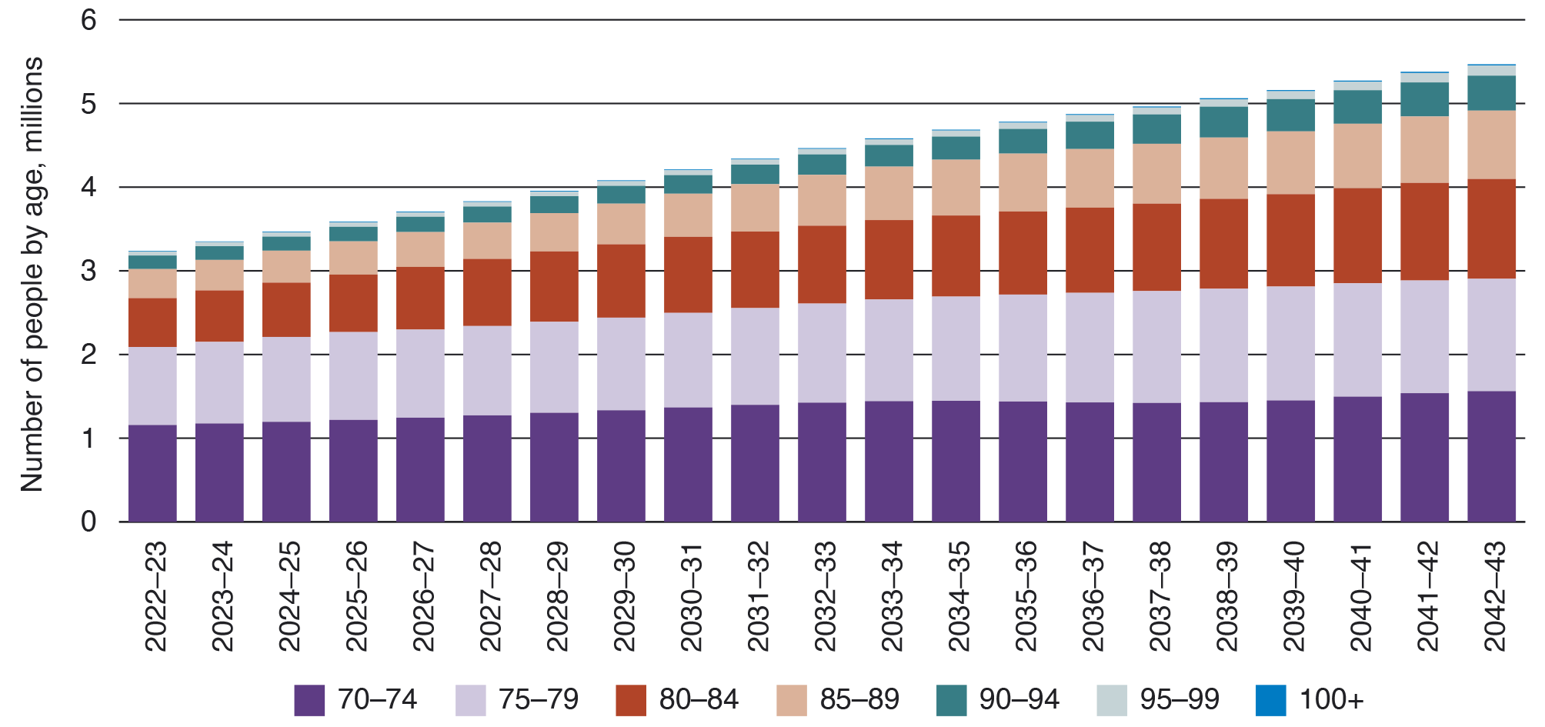

Over the last 20 years there has been a significant shift in preferences from older people for home care over residential care (Chart 2). This trend is expected to continue and accelerate as the availability of home care improves.
Chart 2: Use of home care compared with residential care, people aged 70+, 2000 to 2022
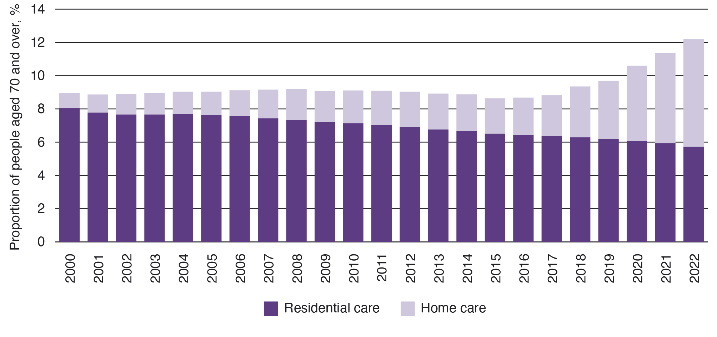
However, the pace at which the population over the age of 70 is projected to increase means there will be growth in the number of people accessing both types of care over the next 20 years (Chart 3).
Chart 3: Projected use of aged care by care type, 2022 to 2042
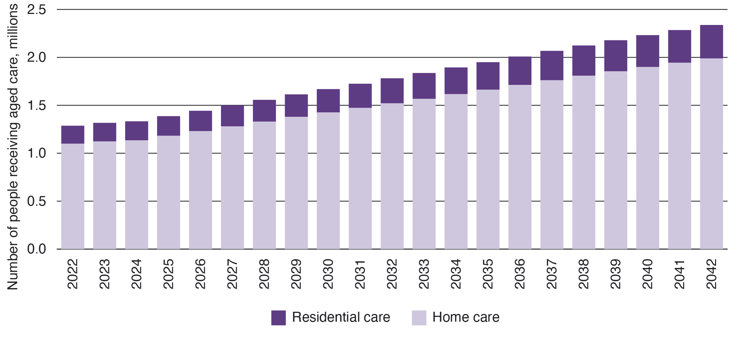

Cost of aged care
Total government spending on aged care in 2021–22 was $24.8 billion. Over 90% of funding goes to the 3 main programs: residential care ($14.6 billion), the Home Care Packages Program ($4.4 billion) and the Commonwealth Home Support Programme ($2.9 billion).
By 2032, projected total government expenditure is expected to more than double with $15.5 billion for the Support at Home Program and $41.2 billion for residential care.
In 2022–23, expenditure on aged care is around $1,000 per person per annum, and is projected to grow (in real terms) to around $3,500 in 40 years.

Pension recipients
Chart 4 shows that over the next 40 years there will be a significant decline in the proportion of people over 65 receiving the full-rate Age Pension, with an increase in part-pensioners and self-funded retirees. However, a significant proportion of older people will continue to receive some pension at retirement, or enter retirement self-funded but become eligible for the Age Pension in their later years.
Chart 4: Persons of Age Pension age or over, by pension category, 2022–23 to 2062–63
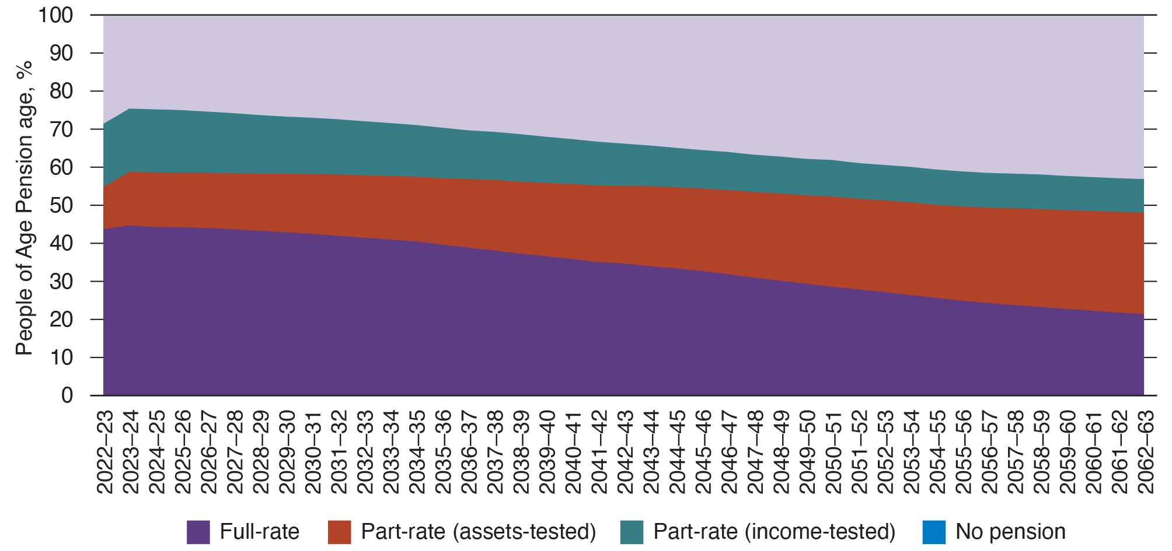

Superannuation
Australia’s compulsory superannuation system was introduced for all employees in 1992 with a superannuation guarantee rate set at 3% of earnings, progressively increasing to 9% in 2002. Further legislated increased will see the rate reach 12% in 2025. Those retiring in 2032 will have had mandatory superannuation savings for 40 years and the effect of the increasing rate will continue to drive greater balances at retirement.
The growth in superannuation balances will increase the capacity to meet expenses later in life. Over the next 20 years, superannuation balances at retirement and age 85 will grow considerably (Chart 5). Balances for people aged 85 are projected to be significant for high wealth people. However, projected median balances at age 85 are sensitive to how retirees draw down their superannuation as income, and a significant proportion of older people in this age group will still have low or no remaining superannuation assets.
Chart 5: Superannuation balances at retirement are projected to increase significantly over the next 20 years and superannuation balances at age 85 are projected to be significant for high wealth people
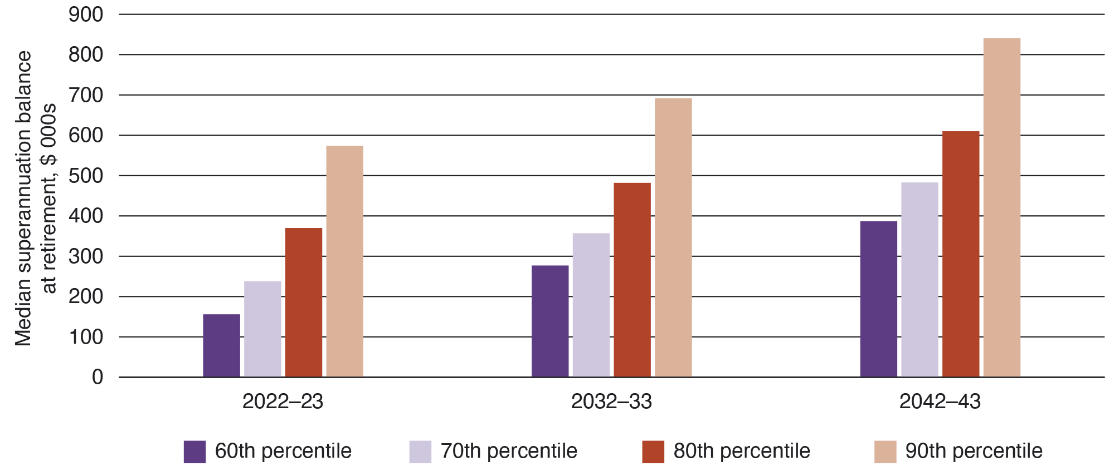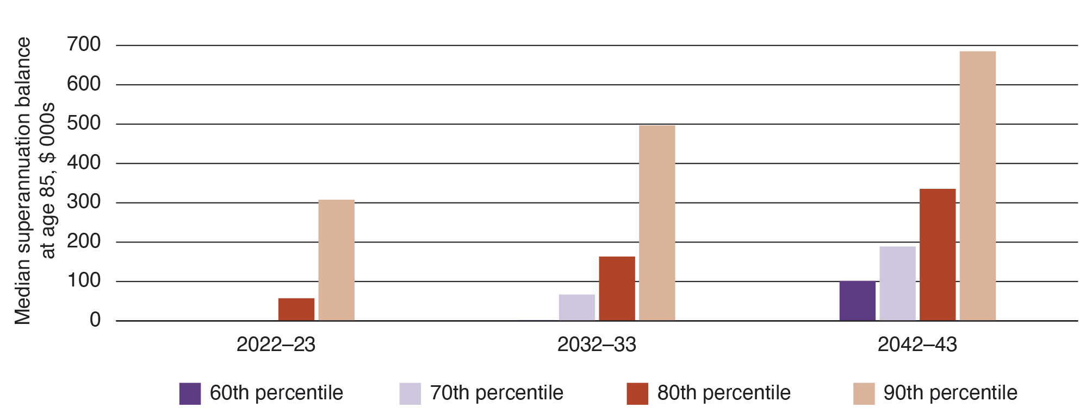

Increasing housing wealth
For most people aged 65 and over, the family home is their largest asset (Chart 6). Excluding the family home, the median retiree household in 2017–18 had around $165,000 in net wealth. However, assets are unequally distributed and wealthier households have a much larger share of their wealth outside the home.
Chart 6: The family home is the largest asset for people aged 65+
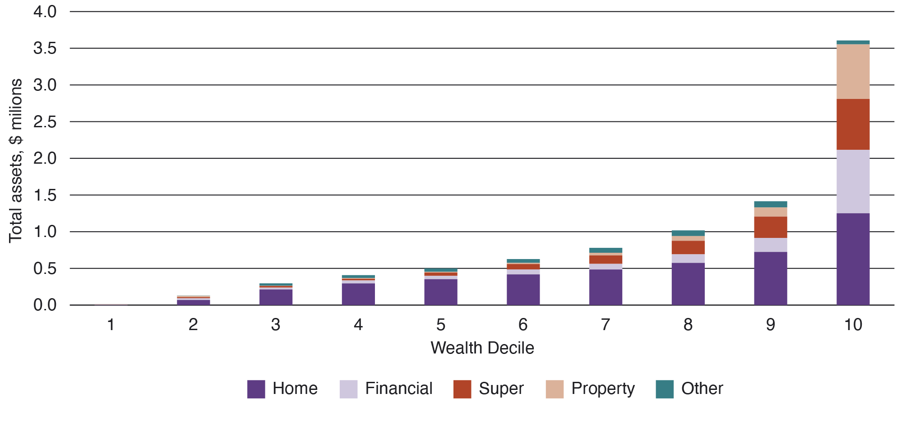
Home ownership rates among those aged 65 years and over remain high compared with younger generations (Chart 7).
Chart 7: Home ownership rates, 1971 to 2021, by 5-year age cohorts
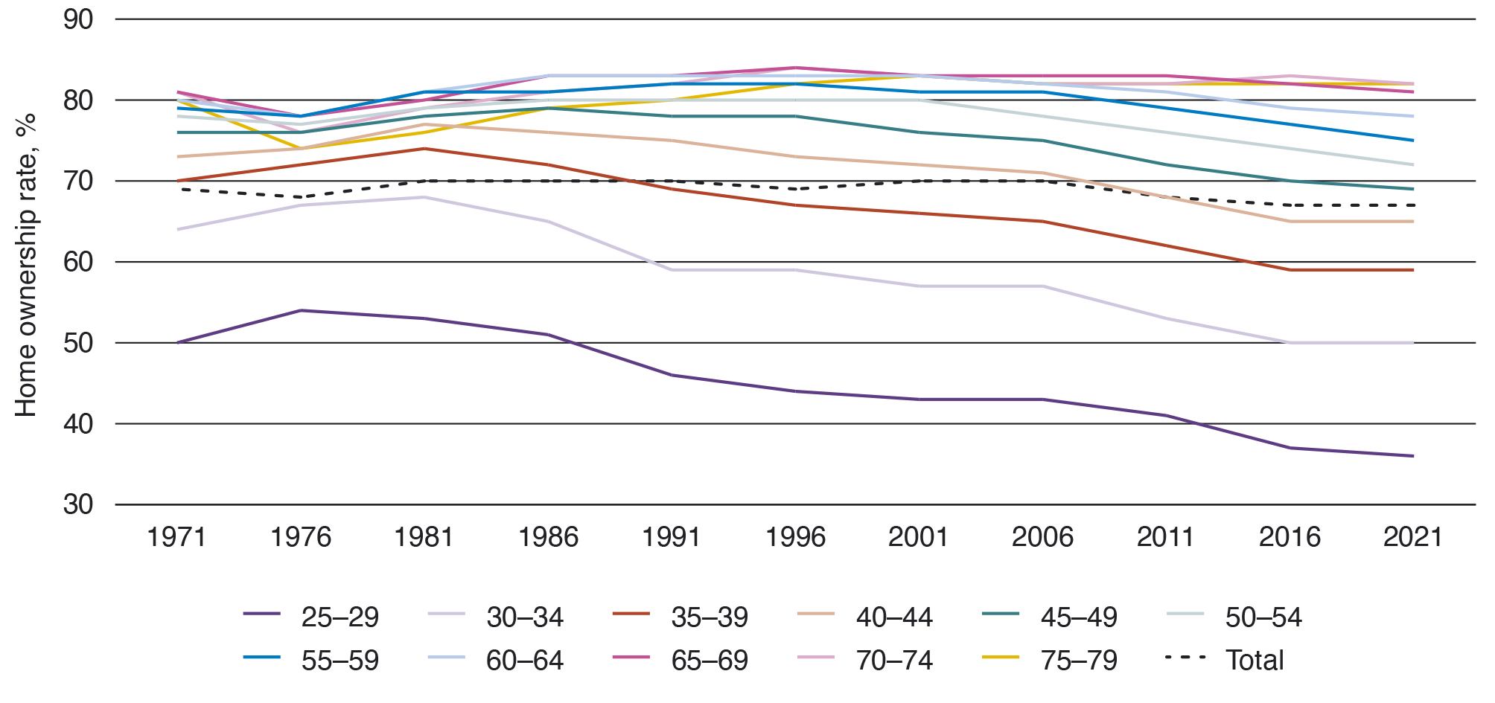

Appendix D: Aged care funding principles
Principle 1: The aged care system should support older people to live at home for as long as they wish and can do so safely.
- Older peoples’ choice to age in place should be appropriately supported, including improving access to and support for the care and services they are assessed as needing to age at home.
Principle 2: Aged care funding should be equitable, easy to understand and sustainable.
- Every older person should be able to receive quality care that meets their needs, irrespective of their financial means, background or geographic circumstances.
- Aged care fees and funding arrangements should be clear and easy to navigate for older people and their support network and providers.
- Overall funding arrangements must be sustainable to meet future demand.
Principle 3: Government is and will continue to be the major funder of aged care. Government funding should be focused on care costs as well as delivering services in thin markets. Personal co-contributions should be focused on accommodation and everyday living costs with a sufficient safety net.
- Government should be the primary funder of care costs in aged care recognising it is a core role of government to ensure people can access services according to their assessed need.
- To meet the growing demand for care there is a need for personal co-contributions from those with the financial means to make them.
- Participant co-contributions should recognise people are generally responsible for services, like accommodation and everyday living costs such as laundry and house cleaning, throughout their lives, with safety nets for those who need assistance.

Principle 4: The residential sector should have access to sufficient capital to develop and upgrade accommodation, including in rural and remote areas and First Nations communities.
- Attracting capital is important to ensure older people have access to high quality residential accommodation. Without sufficient capital investment, the aged care sector will not be able to meet future residential care needs.
- In thin markets, such as rural and remote communities and services for First Nations Australians, the challenge of attracting capital is significant and the role of government may differ geographically. Consideration should also be given to thin markets in metropolitan regions and the distinct challenges they present.
Principle 5: Aged care funding should be sufficient to deliver person-centred, quality care by a skilled workforce.
- Funding arrangements need to enable delivery of quality and appropriate care based on an individual’s needs. This includes delivering culturally appropriate care.
- Australia’s aged care system relies on a skilled and capable workforce. To facilitate this, it is important that providers are positioned to attract and retain workers to deliver high quality, person-centred care.

Principle 6: Aged care funding should support innovation to improve aged care services and their relationship with the health and hospital systems.
- Providers should have sufficient funding to invest in and drive innovative practices and funding should be flexible enough that providers can charge appropriately and have incentives to provide innovative care.
- Aged care depends on smooth interactions with health, hospital and other community services. Improving the system’s interface supports innovation across sectors and increased continuity of care for older people and their families.
Principle 7: There should be transparency and accountability for how aged care funding is received and spent while minimising regulatory burden.
- Transparency and accountability in aged care should ensure older people and their families understand how providers receive and spend funding, and the outcomes delivered with that funding.
- Increased transparency supports the choices of older people by empowering current and prospective aged care participants to make more informed financial and care decisions.
- Regulation has an important role in protecting older people receiving care, but it is important to ensure regulation is not creating excessive burden with limited benefits.

Appendix E: Current aged care participant contributions
Aged care comprises several programs that provide a spectrum of care to older people, ranging from those who require low level supports in the home to the highest level of support and accommodation in residential care. Aged care is available to all older people regardless of their means.
How much an older person contributes depends on which program they are in, their financial position and the provider they choose.

Home care programs
There are currently 2 home care programs:
- Commonwealth Home Support Programme – this helps older people access entry-level support services to live independently and safely at home. An aged care assessment determines eligibility, including specific services.
- Home Care Packages Program – this is a higher level of care that helps older people with complex care needs to live independently and safely in their own homes. Access to this program is determined by an independent assessment by an Aged Care Assessment Team (ACAT). There are 4 levels of Home Care Packages allocated based on assessed care need – from level 1 for basic care needs to level 4 for high care needs. A consumer-directed care approach makes sure the support suits a person’s needs and goals.
Home care providers have other obligations towards their participants, including security of their tenure and ensuring care continuity.
Participants may pay the following:

Commonwealth Home Support Programme
- Co-contributions – These are set by each provider and all providers are required to have a client contribution policy in place. This policy ensures that people who can afford to contribute to the cost of their care do so. It also protects those who are most vulnerable. Providers have discretion as to if, and how much, they charge a participant in line with the Commonwealth Home Support Programme Client Contribution Framework. Participants are not means tested but pension status can be considered by providers.

Home Care Packages Program
- Basic Daily Fee – Everyone receiving a Home Care Package can be asked to pay this depending on their package level. Not all providers charge Basic Daily Fee as this is non-mandatory. Fees are added to the government subsidy to increase the funds available to care recipients in their Home Care Package budget.
- Income tested care fee – An additional amount some participants pay based on their income assessment, which reduces the subsidy government pays. The income assessment includes income, pension and other government payments and deemed income. Daily and lifetime contribution caps apply to the income tested care fee. Only 12% of care recipients incur an income tested care fee.
- Additional fees – Any other amounts agreed between a provider and participant to pay for additional care and services otherwise not covered by the Home Care Packages Program budget. Fees are added to the government subsidy to increase the funds available to care recipients in their Home Care Packages Program budget.

Residential care
A resident’s care needs are assessed by an independent assessor, and the provider is funded to deliver these services. Minimum care minute requirements apply to ensure assessed services are delivered. Participants contribute to the cost of their assessed care needs based on their needs (see ‘means tested care fees’ below).
Residential providers have other obligations towards their participants, including security of their tenure and ensuring care continuity.
Older people in residential aged care may pay the following:
- Basic Daily Fee – An amount that all residents pay for everyday living services (such as meals, laundry and heating). The Basic Daily Fee is capped at 85% of the single rate of the basic age pension for all participants.
- Accommodation costs – This is a means tested payment where supported residents contribute up to the amount of the Accommodation Supplement according to their means and non-supported residents pay a price agreed with the provider. The government pays an Accommodation Supplement for fully supported residents and pays part of the Accommodation Supplement for partially supported residents (accommodation costs paid by partially supported residents reduce the government supplement paid). Non-supported residents pay for their accommodation costs via a fully refundable lump sum RAD or rental style DAP calculated from the lump sum price, or a combination of these 2 payments.
- Means tested care fee – This is a means tested fee, which reduces the amount of government subsidy paid to a provider for the cost of an individual’s care. Annual and lifetime caps apply.
- Additional service fees – Residents can enter into an agreement to pay for services that go beyond the minimum care and service requirements. The scope of these is set and agreed between the resident and provider.
In combination, this means:
- 100% of residents pay the Basic Daily Fee, with 19% paying no other fees
- 81% of residents make some contribution towards their accommodation, with 21% making a partial contribution and 60% paying the full cost
- half of the 60% of residents who pay the full cost also contribute to their care costs.

Appendix F: Glossary of terms
Term | Definition
Accommodation Supplement | The Accommodation Supplement is payable on behalf of residents receiving permanent residential aged care who do not have the capacity to contribute to all or part of the cost of their accommodation.
Aged Care Assessment Team (ACAT) | ACATs carry out comprehensive assessments. ACATs are teams of medical, nursing and allied health professionals. Comprehensive assessments are for people with more complex needs.
Aged Care Quality and Safety Commission (ACQSC) | The ACQSC is an Australian Government statutory authority within the Health and Aged Care portfolio. It is the national regulator of aged care services and the primary point of contact for older Australians and providers in relation to quality and safety.
Australian National Aged Care Classification (AN-ACC) | The government provides subsidies to approved residential aged care providers through the AN-ACC funding model. The AN-ACC model began in October 2022.
Basic Daily Fee (BDF) | Home Care Packages Program: A daily fee anyone can be asked to pay toward their care. This fee is set by the government at a percentage of the single basic Age Pension and it varies depending on the participant’s package level.  Residential aged care: A daily fee payable by all residents as a contribution towards their daily living costs in residential care. The Basic Daily Fee is set at 85% of the single basic Age Pension.
Commonwealth Home Support Programme | This program provides entry-level support services designed to help frail older people stay in their homes. It was introduced on 1 July 2015, consolidating 4 former programs: Commonwealth Home and Community Care (HACC); the National Respite for Carers Program (NRCP); Day Therapy Centres (DTC); and Assistance with Care and Housing for the Aged (ACHA).
Commonwealth Seniors Health Card | A concession card providing cheaper health care and some other discounts for people who have reached Age Pension age and meet certain criteria.
Culturally and Linguistically Diverse Person | Older persons who have particular cultural or linguistic affiliations due to their:  - place of birth or ethnic origin  - main language other than English spoken at home or  - proficiency in spoken English.
Daily Accommodation Payment (DAP) | An amount paid by a non-supported resident towards their accommodation costs in a residential aged care facility calculated daily and paid periodically.
Department of Health and Aged Care | The Australian Government department that administers the Aged Care Act 1997 and regulates the aged care industry on behalf of the government.
Grandparenting arrangements | Grandparenting is a provision where an old rule continues to apply to some existing situations while a new rule will apply to all future cases. Participant co-contribution arrangements are often grandparented in aged care, particularly residential aged care, recognising that people made decisions on entry based on rules that were previously in place.
Gross Domestic Product (GDP) | GDP is the market value of all officially recognised final goods and services produced within a country in a year, or over a given period of time.
Home Care Packages Program | The Home Care Packages Program supports older people with complex ageing related care needs to live independently in their own homes.
Hotelling supplement | A supplement paid to residential care providers on behalf of all residents as a contribution towards their daily living costs. The supplement is paid by government.
Income tested care fee | A daily fee payable by home care participants based on an assessment of their income.
Independent Health and Aged Care Pricing Authority (IHACPA) | The IHACPA is an independent government agency that assists the government to fund hospital and aged care services more efficiently by providing evidence-based pricing determinations and pricing advice. In the aged care context, IHACPA provides residential aged care and respite care pricing and costing advice, RAD approvals and extra service fee approvals.
Low means participant | This refers to recipients of home or residential care who, because of their means, are in receipt of a full or part Age Pension.
Maximum accommodation price | Maximum accommodation prices are set by residential care providers for a room (or bed in a shared room) and published on My Aged Care. These are maximum prices (providers and residents may agree to lower amounts), that apply to residents who are not eligible for government support for their accommodation costs.
Maximum Permissible Interest Rate (MPIR) | The MPIR is a government-set interest rate used to calculate a daily accommodation payment based on an agreed room price. It is used to determine equivalence between a daily payment and a refundable lump sum deposit, giving residents a choice in how to pay.
Means tested care fee | A daily contribution towards the cost of residential care made by residents based on an assessment of their combined income and assets.
Modified Monash Model | A classification system used to determine whether a location is metropolitan, rural, remote or very remote. The model uses a scale from Modified Monash (MM) category 1 (major city) to MM 7 (very remote). MM categories are used to target additional assistance in certain aged care and health programs.
My Aged Care | The main online entry point to the aged care system in Australia. My Aged Care aims to make it easier for older people, their families, and carers to access information on ageing and aged care, have their needs assessed and be supported to find and access services.
Non-supported residents | Non-supported residents are those who have been assessed (based on a means test) as able to pay the full cost of their accommodation and contribute toward their care costs. Non-supported residents pay a Basic Daily Fee, accommodation payment and means tested care fee (they may still receive some assistance with care costs).
Partially supported residents | Partially supported residents are those who have been assessed (based on a means test) as eligible for full government assistance with their care costs, but are able to make a part contribution to their accommodation costs. Partially supported residents pay a Basic Daily Fee and accommodation contribution.
Refundable Accommodation Deposit (RAD) | An amount paid as a lump sum by a non-supported resident for their accommodation costs in a residential aged care facility.
Regional | Geographic region outside of a major city and classified by the Australian Bureau of Statistics as inner regional, outer regional, remote and very remote.

Term | Definition
Residential aged care | A program that provides a range of care options and accommodation for older people who choose not to continue living in their own homes.
Support at Home Program | A new home care program that replaces the current Home Care Packages Program and the Short-term Restorative Care Programme from 1 July 2025, and the Commonwealth Home Support Programme no earlier than 1 July 2027.
Supported residents | Supported residents are those who have been assessed (based on a means test) as eligible for full government assistance with their care and accommodation costs. Supported residents only pay a Basic Daily Fee.


© Copyright Australian Government 2023

Australian Government, Intergenerational Report 2023: Australia’s future to 2063, 2023, p 48.
Australian Government, Intergenerational Report 2023: Australia’s future to 2063, 2023, p 159.
Department of Health and Aged Care, Financial Report on the Australian Aged Care Sector 2021–22, p 21.
Australian Government, Intergenerational Report 2023: Australia’s future to 2063, 2023, p 160.
Department of Health and Aged Care, Financial Report on the Australian Aged Care Sector 2021–22, pp 110–111.
Kantar Public, Consumer contribution to aged care services, 2023.
Department of Health and Aged Care analysis.
Department of Health and Aged Care, Financial Report on the Australian Aged Care Sector 2021–22, p 56.
Department of Health and Aged Care, Financial Report on the Australian Aged Care Sector 2020–21, p 124.
Department of Health and Aged Care, Financial Report on the Australian Aged Care Sector 2021–22, p 34.
Department of Health and Aged Care, Financial Report on the Australian Aged Care Sector 2020–21, p 82.
Australian Government, Intergenerational Report 2023: Australia’s future to 2063, 2023, p 168.
Treasury projections using the Model of Australian Retirement Incomes and Assets.
Superannuation (Objective) Bill 2023.
Australian Institute of Health and Welfare analysis of customised Australian Bureau of Statistics Census data, 2022.
Department of Health and Aged Care, Financial Report on the Australian Aged Care Sector 2021–22, p 28.
Royal Commission into Aged Care Quality and Safety, Final Report: Care, Dignity and Respect, Volume 3B, Commonwealth of Australia, 2021, p 769.
Department of Health and Aged Care, Financial Report on the Australian Aged Care Sector 2021–22, pp 61–62.
Department of Health and Aged Care data, 2023.
Department of Health and Aged Care, Financial Report on the Australian Aged Care Sector 2021–22, table 3.1, p 55.
Royal Commission into Aged Care Quality and Safety, Final Report: Care, Dignity and Respect, Volume 3B, Commonwealth of Australia, 2021, Recommendation 142, p 884.
Department of Health and Aged Care, Financial Report on the Australian Aged Care Sector 2021–22, table 3.1, p 7.
Department of Health and Aged Care data, 2023.
Department of Health and Aged Care data, 2022.
Department of Health, Legislated Review of Aged Care, 2017, p 105.
Australian Research Council Centre of Excellence in Population Ageing Research, Financial decision making for and in old age, 2022, p 19.
IHACPA also considers applications for extra service fees, however, the system is transitioning away from the use of this fee type.
Australian Government, Intergenerational Report 2023: National Population Projections by Age and Sex, 2022–23 to 2062–63.
Department of Health and Aged Care data, 2023.
Department of Health and Aged Care, Financial Report on the Australian Aged Care Sector 2021–22, pp 110–111.
Australian Government, Intergenerational Report 2023: Australia’s future to 2063, 2023, p 223.
This may include Age Pension, Service Pension, Carer Payment and Disability Support Pension.
Australian Government, Intergenerational Report 2023: Australia’s future to 2063, 2023, Chart 7.20.
Treasury projections using the Model of Australian Retirement Incomes and Assets.
Treasury projections using the Model of Australian Retirement Incomes and Assets.
The Treasury, Retirement Income Review, 2020, p 83.
The Treasury, Retirement Income Review, 2020 Chart 1B–6.
Australian Institute of Health and Welfare analysis of customized Australian Bureau of Statistics Census data, 2022.

