Best-Practice Volunteer
Management: A Guide

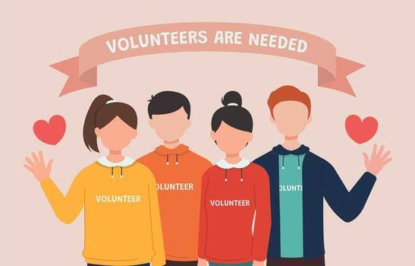

Overview
Globally, volunteering rates have not recovered since the COVID-19 pandemic. As a result, the ability to effectively recruit and retain volunteers is increasingly reliant upon the quality of their management. Applying best-practice strategies in the management of volunteers will almost certainly reduce volunteer disengagement and attrition. This Guide is scaffolded by the National Standards for Volunteer Involvement (the Standards), to ensure that best practice in volunteer management can be communicated and upheld within your organisation.

The National Standards for Volunteer Management
Volunteer leaders are tasked with ensuring that volunteers have everything they need to perform their role, are physically and psychologically safe when working, and are recognised for the important services they provide to their community. Being able to get all this right can be both a large and daunting job. However, the use of the Standards for volunteering ensures that not only the needs of both the organisation and volunteers are met but also provide an easier way forward for the organisation and its volunteers alike.

The Standards were created by Volunteering Australia to inform best practice for volunteer-involving organisations (VIOs) and can be applied to guide and inform the development and implementation of any volunteer program, new or existing.

Organisations and groups can use the Standards in several ways, including:

- As a general guide to improving practice,

- As a checklist to help identify opportunities for making improvements,

- As a framework to assist when planning and creating a new volunteering program,

- As an audit tool to indicate organisational performance, and

- As a baseline from which changes and improvements can be monitored and measured.

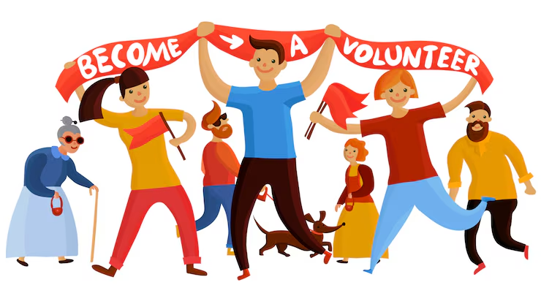

Volunteer Management and the Standards
There are eight Standards that support safe, effective, and inclusive volunteering practices that cover volunteer recruitment, training, and management. This Guide highlights the four Standards that are relevant to the management of volunteers, with the hope that best practice in this area will lead to increased volunteer retention. The Standards being examined in this Guide include:

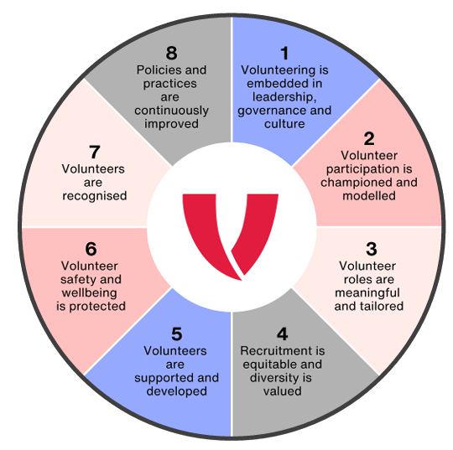
- Standard 1

- Volunteering is embedded in leadership, governance and culture.

- Standard 2

- Volunteer participation is championed and modelled.

- Standard 7

- Volunteers are recognised.

- Standard 8

- Volunteer policies and practices are continuously improved.

Volunteer Management
The importance of excellent volunteer management can’t be underestimated. Research identifies poor leadership as being one of the main reasons volunteers leave their roles. A perceived lack of care and concern, insufficient or out-of-date training, and a lack of recognition are repeatedly cited as being the main issues of poor volunteer leadership.

The key factors that have been identified as creating low volunteer turnover rates and high volunteer satisfaction in organisations include:

- Having a strong culture,

- Having a sense of pride in their purpose and achievements, and

- Actively ensuring that volunteers feel part of their organisation by recognising their individual commitment and contributions.

Research has shown that organisations with low volunteer turnover rates and high volunteer satisfaction:

- Have embedded processes, policies and procedures in place that support the role of volunteers,

- Consider and act upon feedback provided by volunteers, and

- Consistently model the values and attitudes they desire from their volunteers.
By entrenching these essentials into the day-to-day operations of a volunteer-involving organisation, the unspoken psychological contract that underpins all successful workplaces is enacted and respected.

The Psychological Contract
The psychological contract between a volunteer and the organisation they decide to volunteer for begins after they decide to volunteer, but before they begin to volunteer, and is based on the expectations of the volunteering role that are triggered by the organisation itself, through its recruitment information, marketing material, role descriptions, and interactions with potential volunteers.

Essentially, the ‘vibe’ a volunteer-involving organisation creates through its recruitment activities is an expectation in potential volunteers about what the volunteering experience will be like. When this doesn’t match reality, volunteer disengagement and attrition will likely occur. Research shows that the positive experience and productivity of a volunteer is largely determined by the alignment between what the organisation provides to the volunteer and what the volunteer expects of the organisation.

And this is important, because volunteers who have had their psychological contract violated typically tell 10-to-20 other people about the bad experience they’ve had with an organisation. This can result in losing not one volunteer due to poor management, but up to 20 volunteers.

Understanding Psychological Contracts
There are many ways in which the psychological contract between members of a workplace can be violated: from taking someone else’s food from the office fridge, to blaming someone else when a mistake has been made.

When we aren’t paying people to work for our organisations, respecting the psychological contract is the single most important motivational factor in keeping them happy, engaged, and involved. Achieving this means proactively attending to the elements of the psychological contract, such as:

- Defining expectations,

- Providing support,

- Recognising contributions, and

- Promoting flexibility.

Protecting the Psychological Contract
As mentioned earlier, the psychological contract is a set of expectations that the volunteer has for what their experience with an organisation is going to be like. For example, if a recruitment strategy suggests that volunteering with them will be fun, then volunteers will expect to have fun, as this is what has been ‘promised’ if they sign up.

The basic concept is that any relationship (in this case between the volunteer and the organisation) involves unspoken promises and expectations on both sides. When expectations are unmet, dissatisfaction and distrust can follow.

To protect the psychological contract, volunteer leaders need to ensure that they manage:

- Expectations, by

- Being open, honest and transparent about what the role involves – from the time commitment required, to duties and tasks, to the working environment (indoor/outdoor, etc.).

- Ensuring there is clarity regarding timekeeping, the completion of tasks, attendance, and attitude.

- Communication, by

- Ensuring all communications are clear, engaging, and consistent, so that volunteers feel appreciated, informed, and motivated to keep contributing their time.

- Regularly remind volunteers of the reason or purpose of their choice to volunteer in the first place, by providing – and applauding – evidence of their impact.

- Volunteer recognition, by

- Making it meaningful, to not only ensure that volunteers feel appreciated and important, but also to keep them connected to the program, and therefore more likely to continue their involvement.

- Individuals, by

- Managing volunteers in ways they prefer, and which best motivate them.

- Creating a sense of belonging, attachment, and engagement between the volunteer and the organisation.

Volunteering and Identity
When volunteering is seen by an individual as part of their identity, it is much more likely that they will volunteer long term. Termed the “role-person merger”, this state of mind occurs when volunteering is not just an activity someone does, but a fundamental part of who they are (e.g., "I am a volunteer" vs "I volunteer").

Factors contributing to the development of this mindset include:

- Satisfaction and recognition

    - feeling valued, appreciated, and gaining a sense of achievement through the role.

- Social connections

    - developing friendships and a sense of relatedness with other volunteers and staff.

- Meaning and purpose

    - perceiving the role as providing a key purpose or meaning in life.

- Role substitution

    - volunteer roles may become stronger and more meaningful for individuals who have lost other significant roles in their lives, such as those who are retired, widowed, or separated.

To encourage the “role-person merger”, we can:

- Match roles to motives and skills – placing volunteers in positions that align with their personal interests, skills, and availability from the beginning of their volunteering career will help to reinforce their decision to volunteer in the first place.

- Enable a level of ‘job crafting’ – empowering volunteers to proactively shape their roles to better fit their passions and strengths is an important aspect of creating opportunities for volunteer longevity.

- Create a sense of community – fostering a supportive and team focused atmosphere for volunteers will create a sense of being part of a team doing important work together.

- Communicate the impact the volunteer is having on the cause – it is worth regularly sharing success stories, data, and testimonials that highlight the difference and impact that volunteers are making will provide tangible evidence to volunteers that what they are doing, along with the time they are giving.

- Seek out and use volunteer feedback – actively inviting feedback from volunteers and using their insights will demonstrate to them that their opinions are valued, as well as helping the organisation to refine their programs, training, and practices.

- Reinspire volunteers with the cause/mission – periodically reconnecting volunteers with the core purpose of the organisation will help to reignite their passion and remind them of the "why" behind their initial involvement.

Creating the right culture
The culture created by managers is crucial to engaging and retaining volunteers. When volunteers have a sense of belonging and feel their values are reflected in the work they are doing, loyalty and commitment will follow.

A culture of volunteering refers to a shared set of values and actions that prioritises the positive experiences of volunteers. This culture is shaped by the wider values and culture of an organisation, including the attitudes, behaviours, and principles the organisation demonstrates. A positive volunteering culture ensures that volunteers’ needs are met, that they feel respected, that their contributions are valued, and that they’re in an environment which will enable them to develop and thrive.

To determine the kind of culture that currently exists in your organisation, consider whether, and to what extent, the following attributes exist:

- Open, two-way interactions are fostered to enable volunteers to feel empowered and comfortable enough to share their feedback, thoughts, and opinions.

- A safe, supportive, and inclusive environment is cultivated, in which all experiences and views are valued and encouraged.

- Volunteers feel prioritised, appreciated, respected, and valued.

- Volunteers have shared values that align with the purpose and key aims of the organisation.

- Volunteers feel a sense of belonging and responsibility to the organisation.

- A wide range of volunteer skills, experience, and diversity of backgrounds are reflected by the organisation and its local community.

- Regular reviews of volunteer experiences and volunteer feedback occur at executive meetings.

- Volunteers understand, follow, and embody the organisation’s code of conduct, ethics, and policies.

- Regular opportunities exist for volunteers to progress and learn within their role.

Leadership Skills
To create the right volunteer culture in an organisation, and to meet the requirements laid out in the Standards, volunteer leaders need to cultivate and build key skills, including being able to:

- Communicate effectively,

- Empower volunteers,

- Demonstrate fairness and non-judgement,

- Inspire and model appropriate attitudes and behaviours,

- Demonstrate consistency with their efforts and treatment of others, and

- Foster a work environment in which everyone feels valued, respected, and included, regardless of their differences.

While this might seem like a big ask, very often it’s simply self-awareness and behavioural tweaks that make the biggest difference to building the essential skills for excellence in volunteer management. We will look at what this looks like next.

Self-awareness
Self-awareness for volunteer leaders is the ability to understand our own values, emotions, and blind spots, and how they affect our volunteers. And, because volunteer retention relies heavily on motivation and positive culture, a leader's self-awareness directly shapes volunteer engagement, trust, and the overall success of an organisation’s programs.

Practicing self-awareness doesn’t need to be onerous; it simply means:

- Reflecting regularly

- Taking time after events or meetings to review your reactions and decisions, especially when you’ve been challenged.

- Ask for honest input

- Talk to volunteers and peers to learn how your style is truly experienced by those around you.

- Identify personal triggers

- Notice which situations cause you to react with impatience or defensiveness.

- Clarify your motives

- Ensure you lead to empower others, rather than pushing personal agendas.
Essential Skills
The skills listed above are fundamental to good leadership, and can be developed in the following ways if they need to be honed:

- Communicate effectively

- Active listening – focus fully on the speaker without planning your next reply.

- Clarity and brevity – keep spoken and written messages direct and easy to grasp.

- Nonverbal cues – read and use body language, eye contact, and tone effectively.

- Empathy – acknowledge and respect other people's feelings and viewpoints.

- Constructive feedback – offer helpful, objective input, and accept critique gracefully.
- Empower volunteers

- Delegate authority – give volunteers real choices on how to accomplish goals rather than dictating every step.

- Ensure clarity – explain the "why" behind projects, so that volunteers understand how their role connects to larger organisational/community goals.

- Provide resources – supply volunteers with the exact tools, training, and support systems required to complete tasks and fulfil their roles.

- Encourage open dialogue – listen to ideas without judgement and act transparently on volunteer feedback.

- Demonstrate fairness and non-judgement

- Apply consistent rules – use the same standards for everyone, regardless of personal preference or relationship.

- Be transparent – share how and why decisions are made, so the process remains clear and trusted.

- Listen to all voices – give everyone an equal chance to explain their perspective before you reach a conclusion.

- Own your mistakes – admit errors openly and correct unfair choices immediately to rebuild trust.

- Stay curious – ask open questions to understand another person's view instead of jumping to conclusions or making assumptions.

- Inspire and model appropriate attitudes and behaviours

- Be kind and polite to everyone.

- Do what you say you will do.

- Stay calm when things go wrong.

- Listen to others before you speak.

- Use a gentle and clear tone.

- Share your thoughts in an honest way.

- Apologise when you make a mistake.

- Praise people when they do well.

- Help others to learn and grow.

- Treat everyone with an equal level of respect.

- Demonstrate consistency with your treatment of others

- Apply fair standards universally – ensure that rules, rewards, and feedback mechanisms apply to everyone equally.

- Regulate your emotional responses – practice taking a conscious pause under pressure, so your team does not experience erratic shifts from calm to reactive behaviour.

- Communicate transparently and predictably – keep your core message steady across different groups and promptly explain the underlying reasons whenever a shift in direction happens.

- Foster a work environment where everyone feels valued, respected, and included, regardless of their differences

- Lead open conversations.

- Practice active listening.

- Establish clear anti-discrimination policies.

- Value unique perspectives.

- Address unconscious biases.

Summary
Volunteers are at the heart of what we do in our efforts to support our communities. To be an effective volunteer leader, and to create a successful and productive volunteer base, requires not only developing a clear understanding of what volunteers need, but also helping them to identify with the organisation and the role they play in it.

This means taking the time to see volunteers as individuals with a range of unique skills, strengths, needs and goals. Dipping into these unique elements helps us to create a volunteer base that is invested in their work, the impact they have, and the organisation itself.

